West Coast Cities Traveller Series 2022 / 2023
Koombana Bay Sailing Club Heat
Supplementary Sailing Instructions
- Schedule of Races
Competitors Briefing | 1100
First Warning Signal | Not before 1230
Day’s presentations | As soon as possible after all boats have returned to shore
- Locations
  - The race office is in the North-eastern corner of the KBSC clubhouse
  - The official noticeboard is the window to the West of the doors next to the clubhouse bar.
  - Signals made ashore will be flown on the flagpole on the lawn to the North of the clubhouse.
- Start / Finish Line
  - The Start line will be between an orange flag on the race committee boat and an orange flag on a pin buoy at the port end.
  - The finish line will be between an orange flag on the race committee boat and an orange flag on a pin buoy on the committee boat’s port side (i.e. the start line side).
- Marks
  - Marks 1, 2 and 3 will be inflatable pink buoys.
  - Marks 4, 5 and 6 will be inflatable yellow buoys.
- Time limits
  - For the purpose of time limits, Mark 1 shall mean the first mark for each fleet to be rounded. The Mark 1 time limit shall be 30 minutes.
  - The race time limit for the first boat to sail the course and finish shall be 1 hour.
  - The Finishing Window Time limit for boats to finish after the first boat sails the course and finishes, is 20 minutes.
- Class Flags
  - Fleet 1 shall consist of all boats whose skippers were born after 1/04/2007. The fleet 1 course flag will be Numeral Pennant 1.
  - Fleet 2 shall consist of all other boats. The Fleet 2 class flag shall be Numeral Pennant 2.
- Courses
  - The course to be sailed will be triangles with one lap being; Mark 1 – Mark 2 – Mark 3 for Fleet 1 and Mark 4 – Mark 5 – Mark 6 for Fleet 2. The number of laps to be sailed depends on a boat’s AS Yardstick as shown in point 7.3.

  - Course diagram:
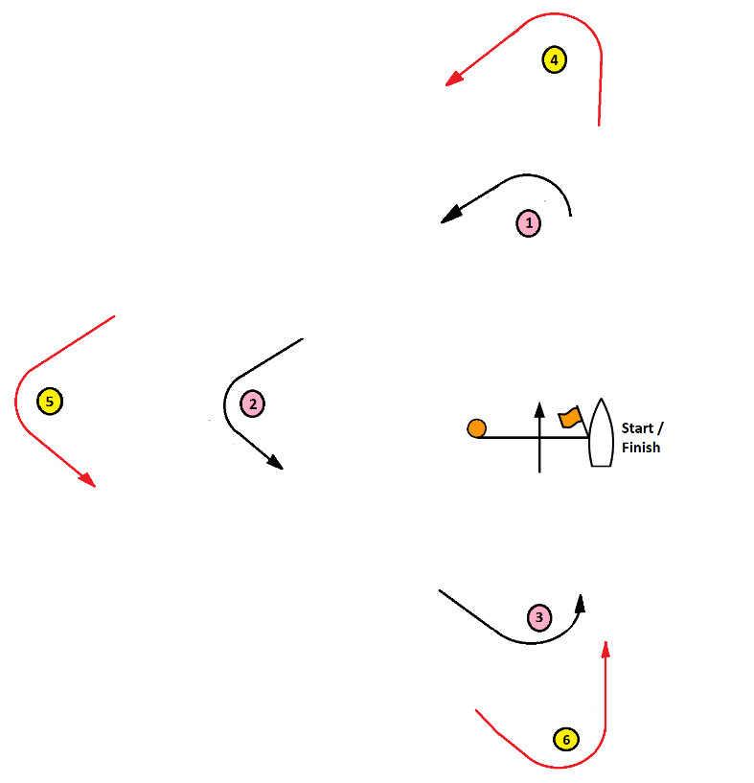
Not to scale
Relative distances and angles will vary
  - Laps required
Class | Yardstick | Fleet 1 laps | Fleet 2 laps
 | >= 160 | 1 | 1
 | >= 150 and < 160 | 2 | 1
 | >= 118 and < 150 | 3 | 2
 | >=96 and < 118 | 4 | 3
Examples | <96 | 4 | 4
Optimist | 170 | 1 | 1
O’pen Skiff | 153.3 | 2 | 1
Mirror | 142 | 3 | 2
RS Feva | 130 | 3 | 2
Pacer | 127.5 | 3 | 2
Laser 4.7 | 125 | 3 | 2
Laser Radial | 118.5 | 4 | 3
Impulse | 118.5 | 4 | 3
RS Aero 5 | 116.8 | 4 | 3
Laser | 114 | 4 | 3
RS Aero 7 | 112.5 | 4 | 3
Tasar | 108 | 4 | 3
Cherub | 100 | 4 | 3
29er | 96.5 | 4 | 3
Sharpie | 95 | 4 | 4
Hobie 14 | 97 | 4 | 4
Hobie 16 | 80.5 | 4 | 4
Nacra 16 sq | 78 | 4 | 4

- Prohibited Sailing
  - If a commercial vessel enters the shipping channel, no boat shall enter the shipping channel. If any boat is already in the shipping channel when a commercial vessel enters the channel, she must leave the channel by the quickest route possible.
  - If an official vessel instructs a boat not to enter the shipping channel or instructs a boat to leave the shipping channel, she must do so immediately.
  - The shipping channel is defined as the area bounded by the entrance to the inner harbour and channel markers A, C, E, F, H, G, D and B as shown in the diagram below.
  - The penalty for failing to comply with supplementary instruction 7.1 or 7.2 will be disqualification without hearing.
