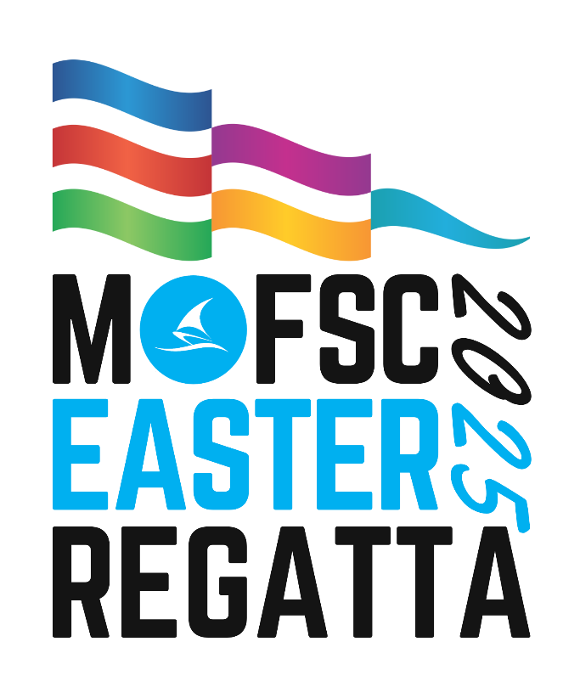

PROGRAM

Race Committee
John McKechnie(Race Officer Bravo Course)
Warren Blay(Race Officer Alpha Course)
Ally Boocock(Regatta Admin & Results)
Bill Bargeboss (ARO & Bravo Course Safety)
Paul Rowley (ARO & Alpha Course Safety)
Dan Flint (On-Land Safety)

Jury
Christina Heydon (NJ), Rob Voss

Organising Committee
Dan Flint (Chairman), Warren Blay, Alex Dixon, Paul Rowley, Annette Walker,
Heather Dunlop-Hol, Kristian Sikora, Ally Boocock

Mandurah Offshore Fishing and Sailing Club
https://mofsc.com.au

Schedule of Events
DATE | TIME | EVENT
Thursday, 17th April | 2400 | Closing of Entries
Friday, 18th April | All Day  1300-1600 | Pre-Regatta Coaching (Class/Club Organised)  Registration
Saturday, 19th April | 0800 - 0900 | Registration / Race Office
 | 0845 | Volunteers / Coaches Briefing
 | 0900 | Competitors Briefing
 | 1030 | 1st Warning signal
 | After racing | Regatta Galley – WAIODA Raffle
Sunday, 20th April | 0845 | Volunteers / Coaches Briefing
 | 0900 | Competitors Briefing
 | 1030 | 1st Warning Signal
 | 1500 | No warning signal after 1500
 | After racing | Pizza supplied by OA and presentation of prizes in the Galley

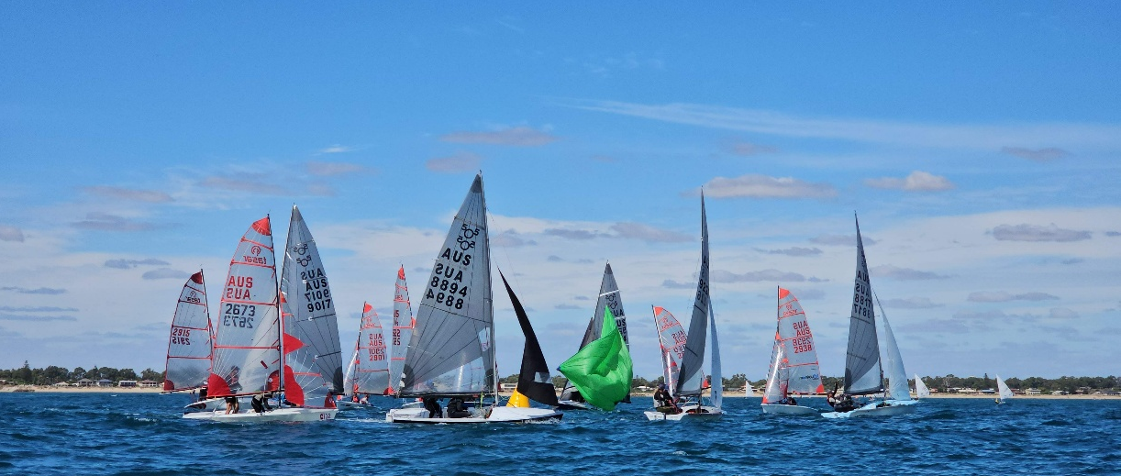

CATERING PROGRAM

HOOK CAFE is located at the front of MOFSC
Food & Drinks
Volunteer’s Lunches can be collected at the Volunteer Briefing each morning.
Prior notification of any special dietary requirements is essential.
CATERING HOURS
Friday 17th April
· Hook Café closed

· Clubhouse Closed
Saturday 18th April
· Breakfast from 0800 in the Hook Café. Bacon and Egg Burgers.
· Hook Cafe open after racing for Burgers, Sausage Sizzles, drinks and snacks.
· Club Menu available in the Restaurant and Bars 1130 - Late
· Bar Open 1130 – Late.
Sunday 20th April
· Breakfast from 0800 - in the Hook Café. Bacon and Egg Burgers.
· Hook Cafe open after racing for Burgers, Sausage Sizzles, drinks and snacks.
Restaurant Closed
· Bar Open 1130 – Late.
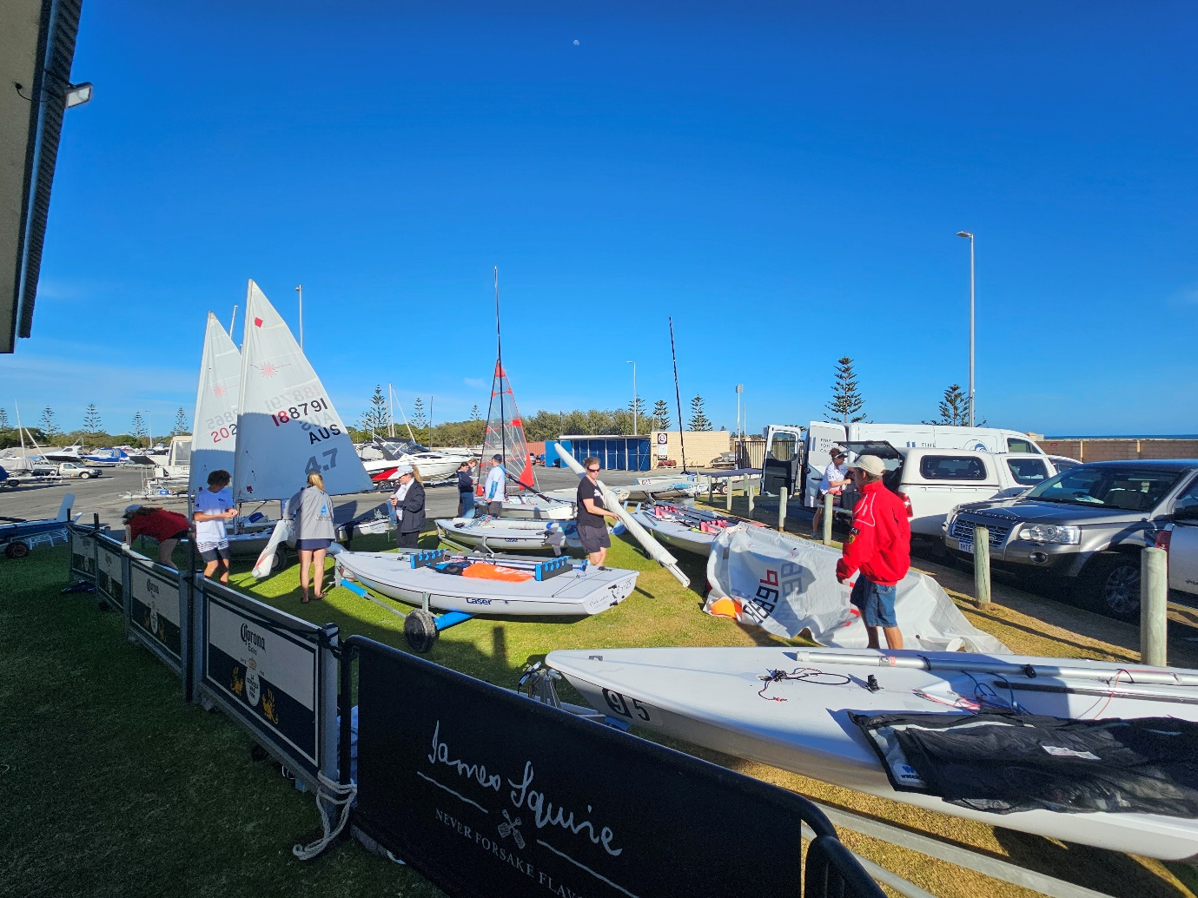

Flags and Start Sequence
Class flags are shown below on their allocated racing areas:

ALPHA COURSE |  | BRAVO COURSE
  Open Skiff |  |   ILCA 4
  Optimist |  |   ILCA 6
  Minnow |  |   ILCA 7
  Alpha Mixed  Fleet |  |   Mixed Fleet

Races will be started in a 3-minute starting sequence as described below. This changes RRS 26.
MINUTES BEFORE STARTING SIGNAL | VISUAL SIGNAL | SOUND SIGNAL | MEANING
3 | Class flag | One | Warning signal
2 | P,U, Black flag | One | Preparatory signal
1 | Prep removed | One long | One minute
0 | Class flag removed | One | Starting signal

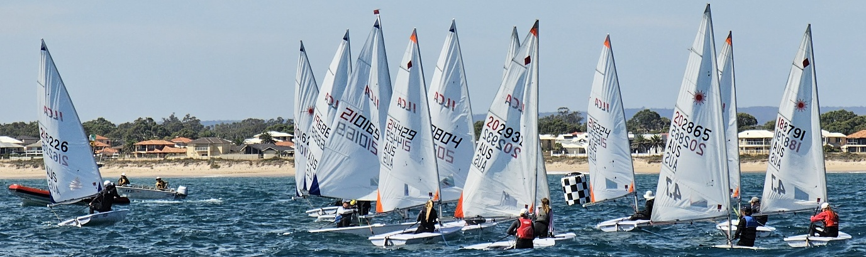

MANDURAH EASTER REGATTA 2025
ATTACHMENT A – Racing Areas
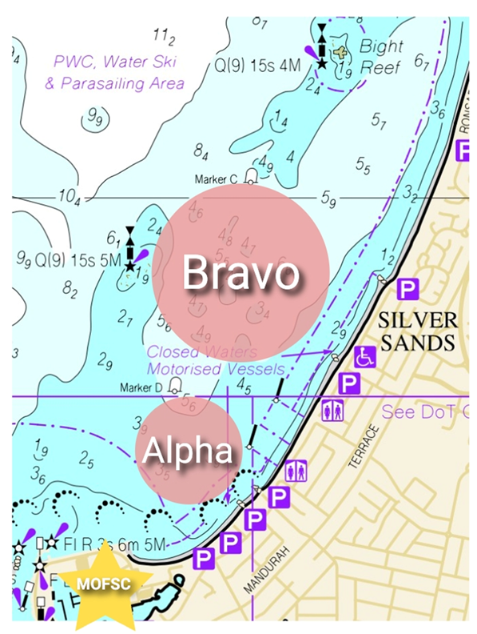

ALPHA COURSE
Open Skiff
Optimist
Minnow
Alpha Mixed
Fleet
ALPHA COURSE
COURSE NOT TO SCALE
CLASS | COURSE | SIGNAL | MARK ROUNDING ORDER
Optimist, Minnow,Mirror | 1 |  | START – 1a – 2s/2p – 1a – FINISH
Optimist, Minnow,Mirror | 2 |  | START – 1a – 2s/2p – 1a – 2s/2p – 1a -FINISH
Open Skiff | 1 |  | START – 1 –2s/2p – 1 – FINISH
Open Skiff | 2 |  | START – 1 – 2s/2p – 1 – 2s/2p – 1 -FINISH
RS Feva | 1 |  | START – 1a – 2s/2p – 1a – 2s/2p – 1a -FINISH
RS Feva | 2 |  | START – 1a – 2s/2p – 1a – 2s/2p – 1a – 2s/2p – 1a -FINISH
BRAVO COURSE

ILCA 4

ILCA 6
ILCA 7
Mixed Fleet
BRAVO COURSE
CLASS | COURSE | SIGNAL | MARK ROUNDING ORDER
All ILCA, Mixed Fleet | 1 |  | START – 1 – 2 –3 -1 -3 -FINISH
All ILCA, Mixed Fleet | 2 |  | START – 1 – 2 –3 -1 – 3 –1 – 2 –3 – FINISH
COURSE NOT TO SCALE

Fleets
Alpha
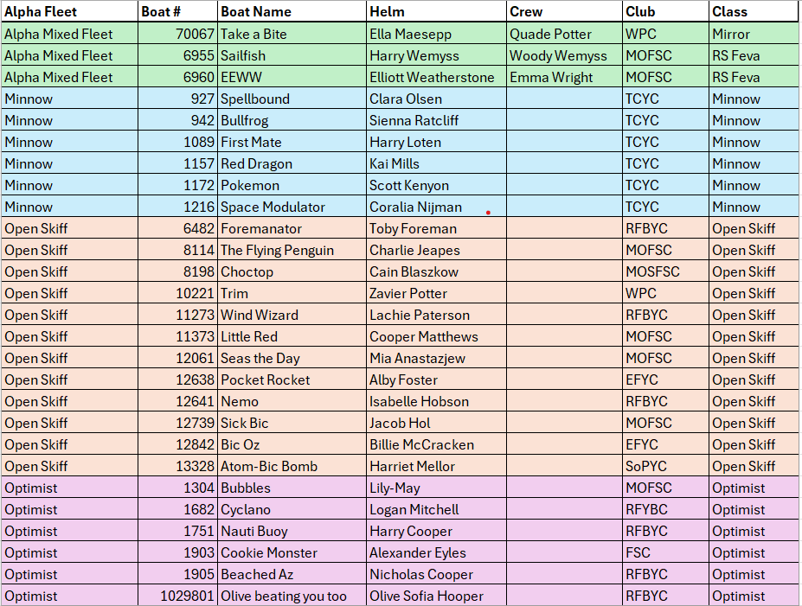

Fleets
Bravo
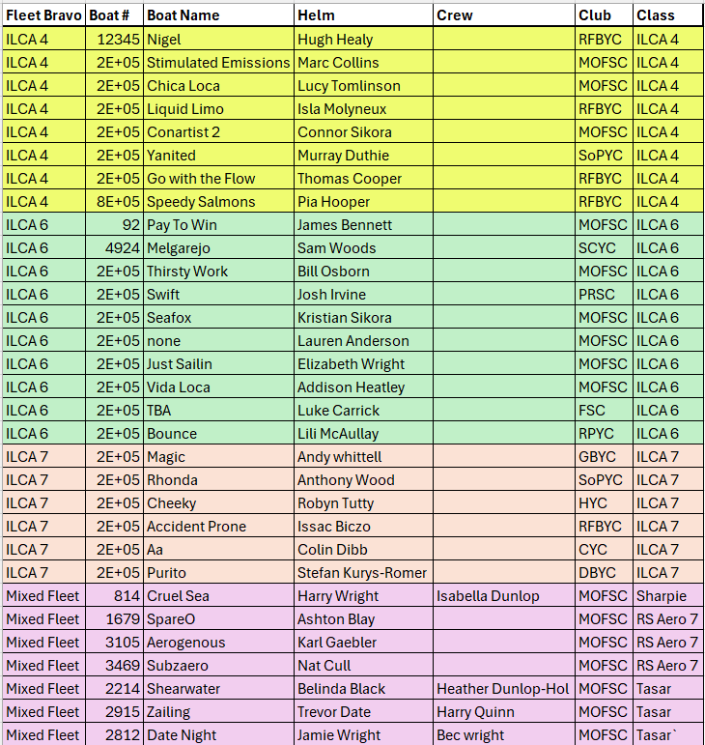


Thank you to our sponsors

