
MEMBERSHIP APPLICATION FORM
Membership Year runs from 1 July – 30 June

Membership category

Ordinary (25 years +) Social
Youth (18-25yrs) Crew (Must be actively crewing on a vessel)
Junior (Up to 18yrs)
Associate (To Junior/ Ordinary or Social Member) Associate to:………………………………………………………………

PRIMARY APPLICANT *For those applying for family memberships, this will be the head member
* Compulsory fields
*Title: Mr Mrs Miss Ms Master *Surname: ………………………………………………………………………………….
*First Name: ……………………………………………………... Preferred name if different: ……………………………………………………..
*Date of birth: ………………………………………………….. Occupation: ………………………………………………….….…………………..
Employer as applicable: ………………………………….…………….…………………….………………………………………………………………………………..
*Residential Address: ..………….…………………..…………………………………………………..................................................................
………………………………………………………………………………………………………………………….. *Post Code: …………….…..…………..……….
Mailing address if different: ..…….…………………..…………………………………………………................................................................
………………………………………………………………………………………………………………………….. Post Code: ……………….……..……………...
*Mobile: ……………………………..……………………………………………………. Preferred Contact Details:………………………………………….…….…
*E-Mail: …………………………………………………..……………………………….. Business Ph: ………………………………………………………………..……..
I confirm that I would like to receive your email newsletter at this email address (please )

Which club activities would you like to participate in?
Power Boating Fishing Diving Cruising Keelboat Sailing / Racing
Dinghy Sailing Adult Social Volunteering Time Trials Dragon Boating
Have you previously been a member of MOFSC? Yes No If so, during which years? ………………………………………………………...
If so, what was your reason for leaving? ……………………………………………………………………………………………………………………………………
Where did you hear about MOFSC? …………………………………………………………………………………………………………………………………………

Are you a member of any other water-activities or sports clubs or associations Yes No
Details:…………………………………………………………………………………………………………………..………………………………………………………………….
PENS/HARDSTAND APPLICATIONS
If you would like to keep your boat at the MOFSC you will need to apply for a pen or hardstand separately.
Your boat and insurance details are required before Members can use the Club’s marina.

ASSOCIATE YES NO * Associate Applicant complete below
HUSBAND/WIFE/PARTNER OF PRIMARY APPLICANT
* Compulsory fields
*Title: Mr / Mrs / Miss / Ms *Surname: ………………………………………………………………………….…………
*First Name: ……………………………………………………................ Preferred name if different: ……………………………………………….……….
*Date of birth: ……………………………………………………………….. Occupation: ………………………………………………………….………….………….
Employer as applicable: ………………………………….…………………………………….……….…………………………………………………………………………
*Mobile: ……………………………..………………………………………….. *E-Mail: …………………………………………………..…………………………..………..
I confirm that I would like to receive your email newsletter at this email address (please )

DECLARATION

I/we would like to receive email communications from the club at the email addresses provided.
Our names, membership categories and mailing address may be published in the Member Register.
In the event of our Membership approval, we agree to abide by the Rules of the MOFSC and any regulations for the time being in force and as parents/legal guardians of the juniors on this application will take responsibility for their behaviour at the club.
Signature of primary applicant: ……………………………………………………………………………………... Date: ……………………………………….…
Signature of husband/wife/partner:…………………………………………………………………………........ Date: ……………………………………….…

REFERENCES (Ordinary members only)
Ordinary members must be proposed and seconded by two other Ordinary members.

We the undersigned consider the applicant to be a person of good character who will honour his/her obligations to the Club.

Proposer name: (PRINT) ……………………………………………………….…………………..………… Member no: ……………………………..…
Proposer signature: ………………………………………………………………………………… ………… Period of time known: ………….……..
Seconder name: (PRINT) …………………………………………………………………………………….. Member no: …………………..……………
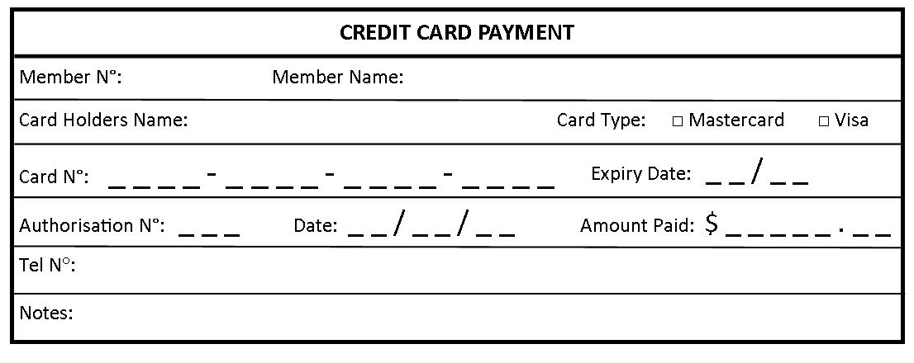
Seconder signature: ………………………………………………………………………………………..…. Period of time known: ………….……..
OFFICE USE: COST OF JOINING INTRODUCED BY STAFF MEMBER: __________________________________
 | Ordinary | Social | Youth | Associate | Crew | Junior 1 | Junior 2 | Junior 3 | Total
Nomination
Subscription
House levy
Capital Asset Levy
Total

Date received: ………………………… Amount to pay: ………………………..… Date paid: ……………………………….

Name 1/ …………………………………… Member Number: ……………………… Card number: …………………………. Gate Access

Name 2/ …………………………………… Member Number: ……………………… Card number: …………………………. Gate Access

S:\~Membership\A - Membership Forms\2024-2025\NEW MEMBERSHIP FORM 2024.docx

