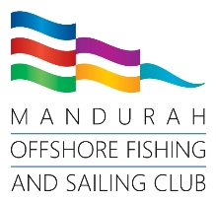



2026 Mandurah Toyota Easter Regatta
3rd April to 5th April 2026
NOTICE OF RACE

Organising Authority (OA)
Mandurah Offshore Fishing and Sailing Club Inc.
supported by
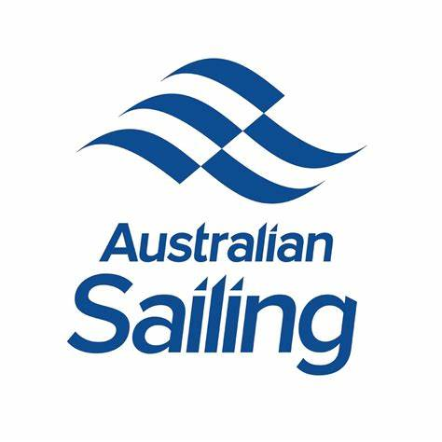


Description of event
The Mandurah Toyota Easter Regatta is a multi-class Sailing and Coaching Regatta conducted by Mandurah Offshore Fishing and Sailing Club Inc. (MOFSC) on the waters of Comet Bay adjacent to the Mandurah Marina.
On water coaching will be permitted during the Regatta by coaches that are registered with their respective classes.
- Rules
  - The Regatta will be governed by the rules as defined in the Racing Rules of Sailing 2025-2028 (RRS).
All competing yachts shall conform to the requirements of AS Special Regulations Part 2 (Off the Beach Boats).
Safety Inspections by the Organising Authority may be carried out at any time.
It will be the responsibility of all competitors to ensure that personal flotation devices comply with a standard equivalent to those listed in Rule 40 Personal Flotation Devices.
Rule 44.1 is changed so that the Two-Turns penalty is replaced by the One-Turn penalty.
The Organising Authority reserves the right to refuse or cancel the entry of a boat to the Regatta in accordance with Rule 76.1.
Appendix P – Special Procedures for Rule 42 may apply.
Appendix P is changed as follows, P2.3 is deleted and the words “or subsequent” are added after the word “second” in P2.2.
Appendix T - Arbitration shall apply.
- Advertising
  - The Organising Authority reserves the right to refuse advertising by any boat, if it is considered offensive to public taste or if it contravenes the laws of the governments of Western Australia or Australia or creates a potential conflict of interest with a Sponsor of MOFSC.
Competitors may be required to display event sponsor’s names(s)/logo(s) and affix bow numbers to boats. If required, the Organizing Authority will supply these items, and they shall be affixed as prescribed in the Sailing Instructions. Sponsor’s bibs will be supplied if required.
- Eligibility
  - The Regatta is open to all classes of Dinghy. 10 or more Dinghies of the same class will constitute a fleet.
  - If, by the closing date, less than 10 entries are received in any class or category, the OA may change the eligibility requirements, cancel that category, or re-allocate or combine entries into a mixed handicap fleet.
  - Dinghies affected will have the option of confirming their entry, or having their entry fee refunded.
  - Where there are sufficient entries, the OA may divide any class or category into further sub-categories.
  - Competitors must be financial members of a yacht or sailing club that is affiliated to, or recognised by Australian Sailing and must hold a current Australian Sailing number.

  - No substitute competitors will be allowed unless written approval is obtained from the Race Committee.
- Entries
  - Boats may enter the regatta by registering online at: https://www.revolutionise.com.au/mofsc/events/327578
  - Entries must be lodged before 1630 on 21st March 2026 to receive the early discount.
To be considered an entry in the regatta, a boat shall complete all registration requirements and pay all fees.
For competitors under 18 years of age at time of the Regatta, a parent (or guardian) shall acknowledge and agree to the Terms and Conditions via the online entry system at the time of entry.
Entries for the Mandurah Easter Regatta close midnight Thursday 2nd April 2026.
- Fees
Regatta fees are listed in table below.
Dinghy Type | Regatta Fee
Single handed classes | $125
Double handed classes | $175
5.2 Entry fee includes pizza at presentations on Sunday.
- Programme
Schedule of Events:
Date | Time | Activity
Friday 3rd April 2026 | All day | Pre-Regatta Coaching – Open to all classes
Saturday 4th April 2026 | 0800 to 0900 | Registration
 | 0845 | Volunteer Briefing
 | 0900 | Competitors Briefing
 | 1030 | First Warning Signal
Sunday 5th April 2026 | 0845 | Volunteer Briefing
 | 0900 | Competitors Briefing
 | 1030 | First Warning Signal
 | 1500 | No warning signal shall be made after 1500
 | After Racing | Presentation Ceremony
The Race Committee intend to sail 4 races per day. Additional races may be sailed at the discretion of the Race Committee.
The Race Committee may elect to change the start time of the following day’s racing based on weather forecasts and the various fleet requirements. A notice advising of any such change will be posted on the Regatta Notice Board and the website no later than 1800 on the preceding race day.
- Measurement
Section not in use for this regatta.
- Sailing Instructions
Sailing Instructions will be available when registering at the Regatta Office at MOFSC and may be posted on the Regatta Notice Board and the Regatta Website prior to registration.
Regatta website: www.mofsc.com.au/on-water/regattas/2026-easter-regatta/
- Regatta Site, Racing Area and Notice Board.
The Regatta site shall be the Mandurah Offshore Fishing and Sailing Club, and the racing area shall be on Comet Bay. Maps and charts of the area and waters will be made available via the Club website and in the Sailing Instructions.
The location of the Regatta Office will be detailed in the Sailing Instructions.
The Regatta Notice Board is located near entrance to the Sundowner Bar 115 Breakwater Parade, Mandurah, WA 6210.
- Courses
The courses shall be triangle, trapezoid and windward/leeward as described in the Sailing Instructions.
- Penalty System refer NOR Section 1
- Scoring
The Low Point scoring system (RRS Appendix A) shall apply.
Eight (8) races are scheduled. Four (4) races are required to be completed to constitute a series.
When from five (5) to eight (8) races have been completed, one race score will be excluded.
Except as modified by the Sailing Instructions, all division prizes will be awarded based on the rankings of competitors in the over-all results of the applicable class.
- Prizes
13.1 Prizes will be awarded to:
- The first three boats in each fleet.
- Additional prizes may be awarded at the discretion of the OA.
- Coach/Support Boats
Except in cases of emergency and a specific request by the Race Officer, coaches and other support boats shall, at all times, keep clear of all competitor’s whilst racing and shall display a green and white flag on their support or coach boat.
Non competitors shall keep clear of the racecourse.
Coach and support boats are required to register with the Organising authority either at the Registration desk or by email to owc@mofsc.com.au
- Radio Communications
  - MOFSC Race Control operates on VHF channel 74. The call sign is. “Mandurah Tower”.
  - All boats that are able should maintain a listening watch on the above channel.
  - A boat engaged in competition or coaching, shall neither make radio transmissions while racing is taking place, nor receive radio communications not available to all boats.
  - Mobile phones or similar devices are prohibited on competing boats.
- Disclaimer of Liability
  - It is the competitor’s decision to enter an event or to start and continue in any race. Competitors shall accept that their participation in an Event is at their exclusive risk in every aspect. See Racing Rule 3, Decision to Race.
  - None of the Organising Authority, their officers, employees, and contractors; members, volunteers, or agents accept any responsibility whatsoever in respect to loss of life, personal injury or damage to property which may be sustained by reason of their participation or intended participation in this event or however arising in connection with the event.
- Warning
Sailing and activities associated with it involve risks of personal injury, loss, damage and death. The risks include but are not limited to the risk of injury from collision, capsizing, falling overboard, being trapped under the sail or boat after capsize, and impact with equipment.
The risks involved in this activity are heightened by:
- Adverse weather conditions
- Inadequate training
- Fatigue
- Inexperience
- Failure to maintain the boat.
- Failure to supply and use the recommended safety equipment.
- Failure to observe the Racing Rules of Sailing or the Sailing Instructions.
This warning is given as a risk warning pursuant to Section 51 of the Civil Liability Act 2002 (as amended). Having given this risk warning, competitors take part in the event entirely at their own risk. Mandurah Offshore Fishing and Sailing Club, its members or representatives will not be held liable for damage or loss of equipment, personal injury, or loss of life, however it may occur.
- Insurance
18.1 All boats competing in the 2026 Mandurah Easter Regatta must have a valid third party insurance policy with a minimum cover of AUD$10,000,000 whilst racing.
18.2 All competitors who submit the Entry Form are deemed to have made declaration that they hold such cover.
18.3 Competitors may be required to provide such details and evidence that they have such insurance in place at the time of the entry.
- Rights to Use Name and Likeness
By participating in the event, a competitor automatically grants the Organising Authority the right in perpetuity to make, use and show, from time to time and at their discretion, any motion pictures, still pictures and live, taped or film television and other reproductions of the athlete during the period of the competition without compensation.
- Changes to Notice of Race
Any changes to this Notice of Race will be published on the regatta website www.mofsc.com.au/on-water/regattas/2026-easter-regatta/ and/or the Club noticeboard.
- Further Information
For further information, please visit mofsc.com.au/regattas or contact:
Event Coordinator
Alex Dixon
Email: owc@mofsc.com.au
Phone: 95356251
Event Director
Dan Flint
Email: rc@mofsc.com.au
Phone: 0400 205 686
Mandurah Offshore Fishing Sailing Club
115 Breakwater Parade
PO.BOX 219
MANDURAH WA 6210
Web site: www.mofsc.com.au
Phone: (08) 95356251
Fax: (08) 95358979
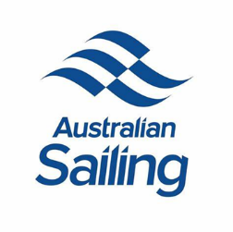
Email: owc@mofsc.com.au

