


2026 Mandurah Toyota Easter Regatta
3rd, 4th and 5th April 2026
SAILING INSTRUCTIONS

SUPPORTED BY:
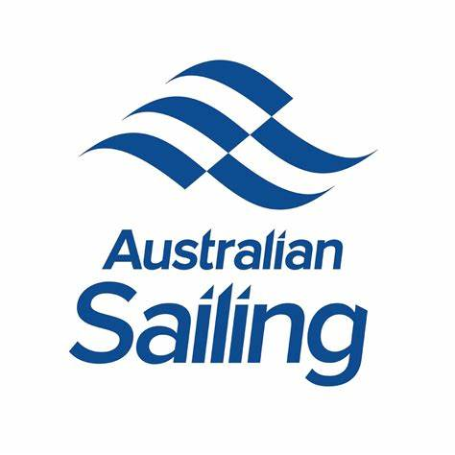


The Organising Authority (OA) is Mandurah Offshore Fishing and Sailing Club Inc.
NP - The notation ‘[NP]’ in a rule means that a boat may not protest another boat for breaking that rule.
SP - The notation ‘[SP]’ denotes a rule for which a standard penalty may be applied by the race Committee without a hearing. This changes RRS A5.
DP - The notation ‘[DP]’ denotes a rule of which the penalty is at the discretion of the protest committee and may be less than disqualification.
- RULES
  - The regatta will be governed by the rules as defined in The Racing Rules of Sailing (RRS), the Australian Sailing Special Regulations Part 2, the rules of the respective Classes (except as any of these are altered by the Sailing Instructions), and by the Sailing Instructions.
  - The Australian Sailing Prescriptions shall apply to all entries.
  - [SP] Australian Sailing Special Regulation Part 2 Off the Beach Boats, will apply. It is the responsibility of all competitors to ensure that life jackets comply with a standard equivalent to those listed in the regulations.
  - Appendix T Arbitration will apply.
  - [DP] Appendix P5.1 applies if the Class Rules apply.
  - [DP] All relevant Class rules will apply. Spot checks can be made by Race Committee at any time.
  - If there is a conflict between the NoR and the SIs, then the SIs shall prevail
  - Penalties at the time of the incident the first two sentences of RRS 44.1 are changed to: ‘A boat may take a One-Turn Penalty when she may have broken one or more rules of Part 2 or RRS 31 in an incident while racing. However, when she may have broken one or more rules of Part 2 while in the zone around a mark other than a starting mark, her penalty shall be a Two-Turns Penalty. ‘for the Part 2 incident.
- CHANGES TO SAILING INSTRUCTIONS
Any change to the SIs will be posted at least two (2) hours before the scheduled time of the first race of the day it will take effect, except that any change to the schedule of races will be posted by 1800 on the day before it will take effect.

- NOTICES TO COMPETITORS
  - Notices to competitors (NTC) will be posted on the official noticeboard (ONB) located at the entrance to the Sundowner Bar.
  - The Race Office is located in the Sundowner Bar (located just inside the doors of the Hook undercover area).
  - On the water, the Race Committee intends to operate on the following VHF channels:
ALPHA COURSE | BRAVO COURSE
74 | 72
- CODE OF CONDUCT
[DP] Competitors and support persons shall comply with reasonable requests from race officials.

- SIGNALS MADE ASHORE
  - Signals made ashore will be displayed at the flag mast on the southern side of the Clubhouse.
  - When flag AP is displayed ashore, ‘1 minute’ is replaced with ‘not less than 45 minutes’ in the Race Signals AP.
  - Signals made ashore for Alpha or Bravo course specific will Fly the Navy Numeral 1 flag for Alpha course or Navy Numeral 2 flag for Bravo course above the relevant signal flag

- SCHEDULE
  - The schedule is as follows:
DATE | TIME | EVENT
Thursday, 2nd April | 2400 | Closing of Entries
Friday, 3rd April | All Day  1300-1600 | Pre-Regatta Coaching  Registration / Race Office
Saturday, 4th April | 0800 - 0900 | Registration / Race Office
 | 0845 | Volunteers / Coaches Briefing
 | 0900 | Competitors Briefing
 | 1030 | First Warning signal
Sunday, 5th April | 0845 | Volunteers / Coaches Briefing
 | 0900 | Competitors Briefing
 | 1030 | 1st Warning Signal
 | 1500 | No warning signal after 1500
  - To alert boats that a race or sequence of races will begin soon, the orange starting line flag will be displayed with one sound at least five minutes before a warning signal is made.

- CLASS FLAGS
Class flags are shown below on their allocated racing areas:
ALPHA COURSE |  | BRAVO COURSE
  Open Skiff |  |   125
  Optimist |  |   ILCA
  Small Mixed Dinghy |  |   Large Mixed Dinghy

Hansa

- RACING AREA
  - SI Attachment A shows the approximate locations of racing areas.
Racing will be conducted over two racing areas – Alpha & Bravo.

- COURSES
SI Attachment B shows the courses, the order in which marks are to be passed, and the side on which each mark is to be left.
If only one bottom mark is present, boats shall round the single mark to port.
The course to be sailed will be designated by the following:

ALPHA COURSE | BRAVO COURSE
Navy numeral pennant | Navy numeral pennant
 | 

- MARKS
ALPHA COURSE |  |  | BRAVO COURSE
1 | Yellow Cone buoy |  | 1 | Orange Tetrahedral buoy
1a | Green Cylinder buoy |  | 2 | Orange Tetrahedral buoy
2 | Orange Tetrahedral buoy |  | 3 | Orange Tetrahedral buoy
3a&b | Yellow Cone buoy

- THE START
11.1 Races will be started in a 3-minute starting sequence as described below. This changes RRS 26.
MINUTES BEFORE STARTING SIGNAL | VISUAL SIGNAL | SOUND SIGNAL | MEANING
3 | Class flag | One | Warning signal
2 | P,U, Black flag | One | Preparatory signal
1 | Prep removed | One long | One minute
0 | Class flag removed | One | Starting signal
The starting line is between a staff displaying an orange flag on the Race Committee vessel at the starboard end and the course side of the port-end starting mark.
[SP][NP] Boats whose warning signal has not been made shall avoid the starting area during the starting sequence for other races.
[SP][NP] After starting a race, a boat shall not sail through the start line in either direction while racing.
A boat that does not start within 3 minutes after her starting signal will be scored Did Not Start (DNS) without a hearing. This changes RRS A5.1 and A5.2.
The starting signal for a class may be the warning signal for a subsequent class.
Classes may be started in any order and combined with other Classes.

- CHANGE OF THE NEXT LEG OF THE COURSE
To change the next leg of the course, the Race Committee will move the original mark (or move the finishing line) to a new position.

- THE FINISH
Alpha Course: The finishing line is between a staff displaying a blue flag on the Race Committee vessel at the port end and the course side of the starboard end finishing mark.
Bravo Course: The finishing line is between a staff displaying a blue flag on the Race Committee vessel at the port end and the course side of the starboard end finishing mark.
[SP][NP] Except when finishing, boats sailing through the finishing line in either direction, while Race Committee vessel is displaying a blue flag will incur a scoring penalty [SP] without a hearing.

- PENALTIES
14.1 The first two sentences of RRS 44.1 are changed to: ‘A boat may take a One-Turn Penalty when she may have broken one or more rules of Part 2 or RRS 31 in an incident while racing. However, when she may have broken one or more rules of Part 2 while in the zone around a mark other than a starting mark, her penalty shall be a Two-Turns Penalty for a Part 2 incident.
For certain breaches of the SIs the Race Committee may apply a standard penalty [SP] without a hearing. The SP for this regatta is 2 points for each breach.

15. PROTESTS
15.1 To facilitate early notification to the protest committee, skippers planning to lodge a protest are required to hail the finish boat as soon as they have finished that race. The race officer will then notify the protest committee Chairman.
15.2 Protests shall be written on forms available at the Regatta Office and delivered to the Regatta Office within 60 minutes from the time the last boat has finished in the last race of that day.
15.3 Parties to a protest will be advised of the time and location of the arbitration and protest hearing. This advice may be given verbally and may be posted on the notice board.
15.4 The Protest Time Limit will be posted on the Admin Notice Board
15.5 Protest arbitration may be used for this event, which if used, will be held at the Regatta Office soon after protest forms are lodged and will be conducted in accordance with the rules.
15.6 Protestors must lodge forms with the Regatta Office. The protestor must wait to receive 2 copies of the protest – one for themselves, and the other to deliver to the protestee. It is the protestor’s responsibility to bring the protestee back to the office for the arbitration hearing as required.

16. TIME LIMITS
Boats failing to finish within 15 minutes after the first boat finishes will be scored ‘Did Not Finish’. This changes RRS 35 & A5.

17. SERIES
A Series shall be in accordance with the tables below:
ALPHA COURSE |  |  |  | BRAVO COURSE
Races in series | 8 |  | Races in series |  | 8
Races to constitute a series | 3 |  | Races to constitute a series |  | 3
Discards after 4 races | 1 |  | Discards after 4 races |  | 1

- . [DP] SAFETY REGULATIONS
A boat that retires from a race shall notify the Race Committee at the first reasonable opportunity. Promptly after returning to shore, the boat shall complete a retirement declaration form, which is available at the Race Office.

- SIGN ON/OFF
  - [SP] Skipper or Crew of a Boat shall sign on at the Sign On Board before leaving the shore.
  - [SP] Skipper or Crew of a Boat shall sign off at the Sign On Board after returning to the shore.
  - The Sign On Board is located outside the Race Office.
  - [DP][NP] Parents, coaches or any support person shall not sign on or off for the crew of a boat at any time. The penalty for a boat for a breach of this SI will be at the discretion of the Protest Committee who may take advice from the RC and RO, up to and including disqualification from the race nearest the breach or event.

- [DP]REPLACEMENT OF CREW OR EQUIPMENT
Substitution of damaged or lost equipment is not allowed unless previously authorised in writing by the Race Committee. Requests for substitution shall be made to the Race Committee at the first reasonable opportunity in Writing stating the reason and should include a photo of the damage.

- [DP]SUPPORT BOATS - See Attachment C

- TRASH DISPOSAL
Trash may be placed aboard official vessels.

- DISCLAIMER OF LIABILITY
23.1 Competitors participate in the regatta entirely at their own risk.
23.2 Competitors attention is drawn to RRS 3 – Decision to race. RRS 3 states: ‘The responsibility for a boat’s decision to participate in a race or to
continue to race is hers alone.’ By participating in this event each competitor agrees and acknowledges that sailing is a potentially dangerous activity with inherent risks. These risks include strong winds and rough seas, sudden changes in weather, failure of equipment, boat handling errors, poor seamanship by other boats, loss of balance on an unstable platform and fatigue resulting in increased risk of injury. Inherent in the sport of sailing is the risk of permanent, catastrophic injury or death by drowning, trauma, hypothermia or other causes.23.3 It is the competitors’ decision to enter the Event or to start and continue in any race. Competitors shall accept that their participation in the Event is at their exclusive risk in every aspect. By way of entry in the Event competitors must indemnify the Organising Authority their Offices, members, staff, volunteers and agents in respect to all claims and demands of whatever nature which may be made upon them in connection with or howsoever arising from their participation or intended participation in the Event.
23.4 Competitors are responsible for the seaworthiness of the boat that they are sailing and for the sufficiency and adequacy of its equipment for the prevailing conditions.
23.5 The Organising Authority their offices, members, staff, volunteers and agents accept no responsibility in respect to loss of life, personal injury or loss or damage of property which may be sustained by reason of their participation or intended participation in the Event howsoever arising in connection with the Event.

- FURTHER INFORMATION
Alex Dixon – On Water Coordinator
115 Breakwater Parade
Mandurah 6210
0492 905 420
owc@mofsc.com.au

MANDURAH EASTER REGATTA 2025
ATTACHMENT A – Racing Areas
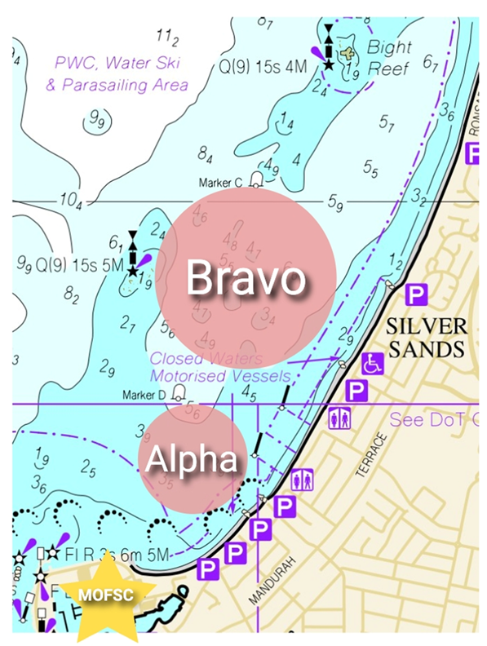
Attachment B – Courses ALPHA COURSE
CLASS | COURSE | SIGNAL | MARK ROUNDING ORDER
Open Skiff /RS Feva/ Flying Ant | 1 |  | START – 1- 1a – 3s/3p – 1- 1a – FINISH
Minnow | 1 |  | START – 1- 1a – FINISH
Open Skiff /RS Feva /Flying Ant | 2 |  | START – 1-1a – 3s/3p – 1- 1a – 3s/3p – 1-1a -FINISH
Minnow | 2 |  | START – 1- 1a – 3s/3p – 1- 1a – FINISH
Open Skiff / RS Feva / Flying Ant | 3 |  | START – 1 – 2 – 3 – 1 – 3 -FINISH
Minnow | 3 |  | START – 1 – 2 – 3 -FINISH
Open Skiff / RS Feva / Flying Ant | 4 |  | START – 1 – 2 – 3 – 1 – 3 – 1 – 2 - 3 -FINISH
Minnow | 4 |  | START – 1 – 2 – 3 – 1 – 3 -FINISH
Optimist | 1 |  | START – 2 –3s/3p – 2 – FINISH
Optimist | 2 |  | START – 2 – 3s/3p – 2 – 3s/3p – 2 -FINISH
Optimist | 3 |  | START – 1 – 2 – 3 -FINISH
Optimist | 4 |  | START – 1 – 2 – 3 – 1 – 3 -FINISH

Small Mixed Dinghy Fleet
Flying Ants, RS Fevas, Minnows

Large Mixed Dinghy Fleet
Tasars, Aeros, Sharpies

Attachment B – Courses ALPHA COURSE

COURSE NOT TO SCALE

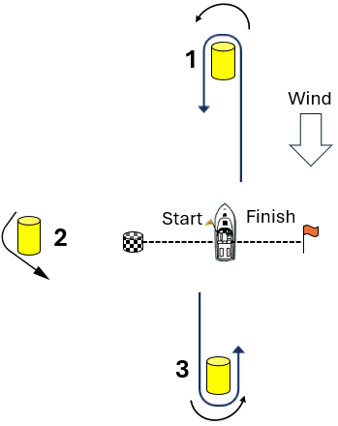
Courses 1&2 Courses 3&4
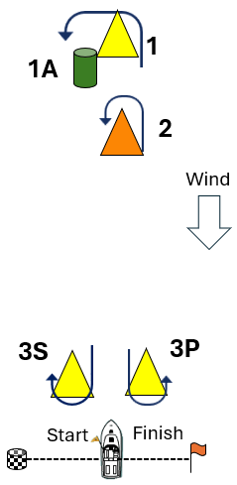

Attachment B – Courses BRAVO COURSE
CLASS | COURSE | SIGNAL | MARK ROUNDING ORDER
125, ILCA, Large Mixed Dinghy | 1 |  | START – 1 – 2 –3 -1 -3 -FINISH
125, ILCA, Large Mixed Dinghy | 2 |  | START – 1 – 2 –3 -1 – 3 –1 – 2 –3 – FINISH
Hansas | 1 |  | START – 1 – 2 –3 -FINISH
Hansas | 2 |  | START – 1 – 2 –3 -1 -3 -FINISH

COURSE NOT TO SCALE

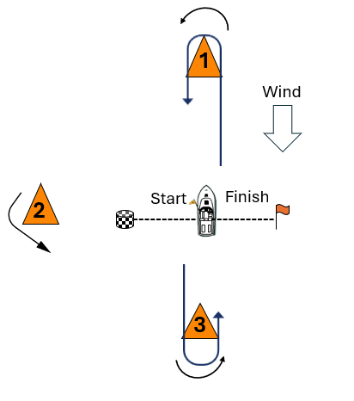

ATTACHMENT C - SUPPORT TEAMS [DP]

Support Teams, including all Support Persons, Coaches, Team Leaders and their vessels, shall comply with the following:

- All vessels shall be registered with the OA by emailing: owc@mofsc.com.au
- All vessels will be required to comply with local marine legislation. Local marine regulations specify the safety equipment to be carried. A copy of the regulations is available at:
https://www.transport.wa.gov.au/imarine/boating-safety.asp
- All vessels shall only be moored in the location as directed by a MOFSC representative.
- Except for those coaches and support vessels who are registered and accredited by MOFSC, other vessels shall stay outside areas where boats are racing from the time of the preparatory signal for the first start until all boats have finished or retired or the Race Committee signals a postponement, general recall or abandonment.
- No one on a support vessel is to communicate or signal in any way to a competitor from the warning signal until after finishing a race.
- Each vessel shall be insured with valid third-party liability insurance with a minimum cover of $10 million per incident or the equivalent.
- All skippers and their crews shall wear a personal flotation device securely fastened at all times when afloat.
- All vessels will be required to assist in the event of an emergency as directed by the Race Management Team.
- All support vessels shall have a working VHF radio and maintain a listening watch on the nominated VHF Channel/s.
- All support vessel skippers shall:
- attend the daily Volunteers Briefing with the Race Management Team.
- wear an engine kill cord/safety lanyard or automatic engine immobilizer.
- all persons on a Support Vessel must wear approved PFD’s at all times.
- hold a current RST or equivalent powerboat licence.
- The penalty for failing to comply with the above requirements may, after protest, be applied to the race nearest the breach or event and may be up to and including the disqualification of all competing boats associated with the infringing vessel or support person.

