
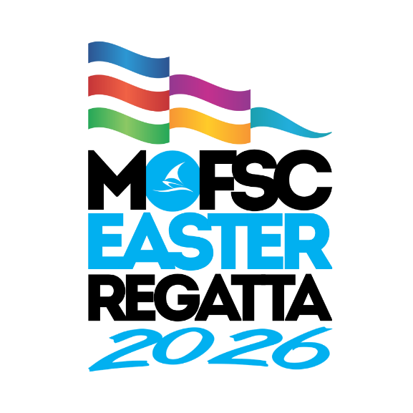

2026 Mandurah Toyota Easter Regatta
PROGRAM

Race Committee

John McKechnie (Race Officer Bravo Course)
Bill Bargeboss (ARO & Bravo Course Safety)
Les Woods (Race Officer Alpha Course)
Warren Blay (ARO & Alpha Course Safety)
Ally Boocock (Regatta Admin & Results)
Dan Flint (On-Land Safety)

Jury
Christina Heydon

Organising Committee
Dan Flint (Chairman), Alex Dixon, Annette Walker,
Heather Dunlop-Hol, Kristian Sikora, Ally Boocock, Aileen Fallon, Paul Rowley

Mandurah Offshore Fishing and Sailing Club
https://mofsc.com.au

Schedule of Events
DATE | TIME | EVENT
Thursday, 2nd April | 2400 | Closing of Entries
Friday, 3rd April | All Day  1300-1600 | Pre-Regatta Coaching  Registration / Race Office
Saturday, 4th April | 0800 - 0900 | Registration / Race Office
 | 0845 | Volunteers / Coaches Briefing
 | 0900 | Competitors Briefing
 | 1030 | 1st Warning signal
Sunday, 5th April | 0845 | Volunteers / Coaches Briefing
 | 0900 | Competitors Briefing
 | 1030 | 1st Warning Signal
 | 1500 | No warning signal after 1500
 | After racing | Pizza supplied by OA and presentation of prizes in the Galley

CATERING PROGRAM

HOOK CAFE is located at the front of MOFSC
Food & Drinks
Volunteer’s Lunches can be collected at the Volunteer Briefing each morning.
Prior notification of any special dietary requirements is essential.
CATERING HOURS
Friday 17th April
Hook Café closed
Clubhouse closed
Saturday 18th April
Breakfast from 0800 in the Hook Café. Bacon and Egg Burgers.
Hook Cafe open after racing for Burgers, Sausage Sizzles, drinks and snacks.
Club Menu available in the Restaurant and Bars 1130 - Late
Bar Open 1130 – Late.
Sunday 20th April
Breakfast from 0800 - in the Hook Café. Bacon and Egg Burgers.
Hook Cafe open after racing for Burgers, Sausage Sizzles, drinks and snacks.
Pizzas supplied at presentations
Restaurant Closed
Bar Open 1130 – Late.
Flags
Class flags are shown below on their allocated racing areas:
ALPHA COURSE |  | BRAVO COURSE
  Open Skiff |  |   125
  Optimist |  | 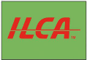  ILCA
  Small Mixed Dinghy |  | 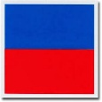  Large Mixed Dinghy

Hansa

Small Mixed Dinghy Fleet
Flying Ants, RS Fevas, Minnows

Large Mixed Dinghy Fleet
Tasars, Aeros, Sharpies

ALPHA COURSE | BRAVO COURSE
Navy numeral pennant | Navy numeral pennant
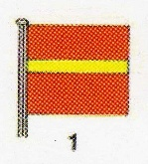 | 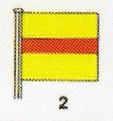
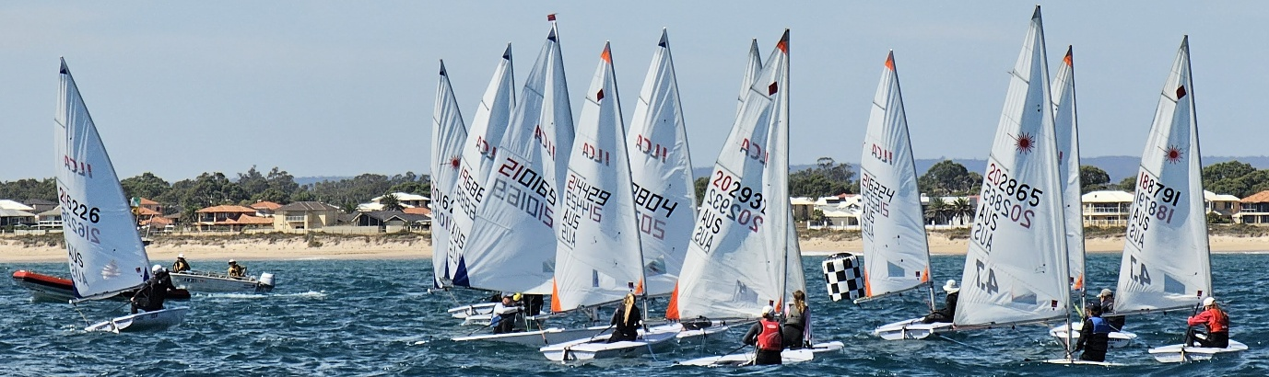
ALPHA COURSE
CLASS | COURSE | SIGNAL | MARK ROUNDING ORDER
Open Skiff /RS Feva/ Flying Ant | 1 |  | START – 1- 1a – 3s/3p – 1- 1a – FINISH
Minnow | 1 |  | START – 1- 1a – FINISH
Open Skiff /RS Feva /Flying Ant | 2 |  | START – 1-1a – 3s/3p – 1- 1a – 3s/3p – 1-1a -FINISH
Minnow | 2 |  | START – 1- 1a – 3s/3p – 1- 1a – FINISH
Open Skiff / RS Feva / Flying Ant | 3 |  | START – 1 – 2 – 3 – 1 – 3 -FINISH
Minnow | 3 |  | START – 1 – 2 – 3 -FINISH
Open Skiff / RS Feva / Flying Ant | 4 | 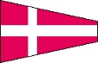 | START – 1 – 2 – 3 – 1 – 3 – 1 – 2 - 3 -FINISH
Minnow | 4 |  | START – 1 – 2 – 3 – 1 – 3 -FINISH
Optimist | 1 |  | START – 2 –3s/3p – 2 – FINISH
Optimist | 2 |  | START – 2 – 3s/3p – 2 – 3s/3p – 2 -FINISH
Optimist | 3 |  | START – 1 – 2 – 3 -FINISH
Optimist | 4 |  | START – 1 – 2 – 3 – 1 – 3 -FINISH

ALPHA COURSE

COURSE NOT TO SCALE

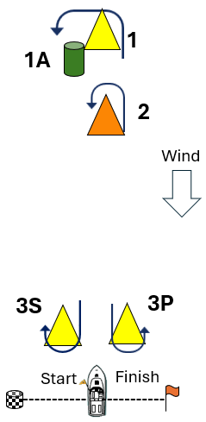
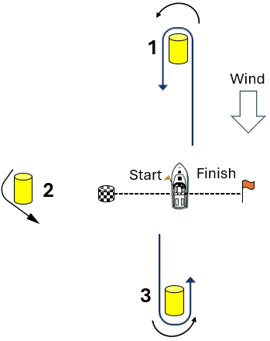
Courses 1&2 Courses 3&4

BRAVO COURSE
CLASS | COURSE | SIGNAL | MARK ROUNDING ORDER
125, ILCA, Large Mixed Dinghy | 1 |  | START – 1 – 2 –3 -1 -3 -FINISH
125, ILCA, Large Mixed Dinghy | 2 |  | START – 1 – 2 –3 -1 – 3 –1 – 2 –3 – FINISH
Hansas | 1 |  | START – 1 – 2 –3 -FINISH
Hansas | 2 |  | START – 1 – 2 –3 -1 -3 -FINISH

COURSE NOT TO SCALE
