

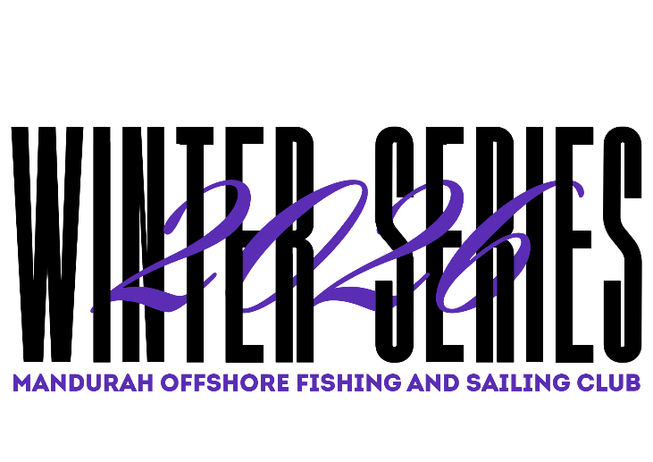

Dinghy Winter Series
NOR 2026
Amended 18/05/2026

Organising Authority:
Mandurah Offshore Fishing & Sailing Club (MOFSC)

 | Date | Senior & Juniors
 | 24th May | Heats 1 & 2
 | 7th June | Heats 3 & 4
 | 21st June | Heats 5 & 6
 | 5th July | Heats 7 & 8
 | 19th July | Heats 9 & 10
2nd August |  | Heats 11 & 12
 | 16th August | Resail if needed

NOTICE OF RACE
1 RULES
  - The regatta will be governed by the current rules as defined in The Racing Rules of Sailing, the special regulations of Australian Sailing, the rules of the applicable classes and by the Sailing Instructions.
  - The Sailing Instructions and any supplementary sailing instructions will be available prior to the first the day of sailing.
  - Any changes to Sailing Instructions will be posted on the official notice board in the foyer in the Southwest of the club.

- ELIGIBILITY AND ENTRY
  - The Series is open to (but not limited to) all boats of the following classes: Optimist, Open Bic, ILCA, RS Aero, Mirror, Tasar, Pacer, Sharpie, RS Feva, Hobie Wave, Minnow, Flying Ant.
  - Eligible boats may enter by completing the on-line entry/registration form at the following Web Address 2026 Winter Series - Registration
  - Competitors must be financial members of a yacht or sailing club affiliated with Australian Sailing and hold a current Australian Sailing Number.

- FEES
  - $10 per race $50.00/Dinghy for the Series

- SCHEDULE
  - Twelve races are scheduled for the Winter Series.
  - Aim for two races per race day, however, is at the discretion of the Race Officer
  - Start time is 10.00am for the first race. The second and any subsequent races will start as soon as possible after the preceding race.

- SAILING INSTRUCTIONS
  - The Sailing Instructions and Supplementary Sailing Instructions will be available on the MOFSC web site.

- RACING AREA
  - The Racing Area will be the waters of Mandurah Estuary or adjacent to Dodi’s Beach

- THE COURSES
  - The courses shall be decided on the day of racing by the Race Officer and communicated at the 9am briefing.

- PENALTY SYSTEM
  - Rule 44.1 is amended in that only one turn, including one tack and one gybe is required.

- SCORING
  - Consistency
    - The Low Point scoring system, RRS Appendix A (Scoring) will apply.
    - The Australian Sailing Dinghy Yardstick System 2025-2026, and the Australian Sailing OTB Cat Yardstick System 2025-2026 shall be used in this series for placing calculations.
    - 6 races are required to be completed to constitute a series.
    - When fewer than 7 races have been completed, a boat’s series score will be the total of her race scores.
    - When from 7 to 9 races have been completed, a boat’s series score will be the total of her race scores excluding her worst score.
    - When 10 to 12 races have been completed, a boat’s series score will be the total of her race scores excluding her two worst scores.

- SUPPORT BOATS
  - Support/coach boats shall be marked with green/white rescue flags.

- JUNIOR & SENIOR FLEETS
  - A junior is defined as a person being under the age of 18 as of the 17th of August 2026
  - A junior that has registered and is the helmsman, may nominate a senior as crew for the series, or part thereof.

- PRIZES
  - Prizes awarded for the Consistency Series include Senior 1st: Junior 1st and other places dependent on fleet numbers.
  - Pennants for Championship and Consistency may be awarded at the conclusion of the end of each set of heats.
  - Prizes for Consistency are to be awarded at the end of the regatta.
  - Additional prizes may be awarded at the organiser’s discretion.

- DISCLAIMER OF LIABILITY
  - All those taking part in this event do so at their own risk and responsibility. The Organising Authority, MOFSC or its agents are not responsible for the seaworthiness of a boat, whose entry is accepted, or the sufficiency or adequacy of its equipment. The Organising Authority, MOFSC or its agents reserves the right to refuse an entry and special attention are drawn to Rule 3 in RRS – Decision to Race. Insurance Each participating boat shall be insured with valid third-party liability insurance with minimum cover of AUD $10,000,000 per incident. By completing and signing the entry form, all owners and/or competitors are deemed to have made a declaration that they hold such cover.

- FURTHER INFORMATION
  - Kristian Sikora - 0402082732 - CD@mofsc.com.au
  - Alex Dixon - 95356251 - OWC@mofsc.com.au
  - Ally Boocock - 0432639376 - allyboocock@gmail.com

