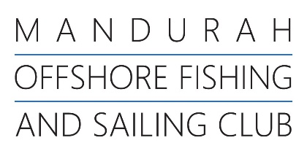




Change to Sailing Instructions
MOFSC Winter Series 2026

Date Posted: 15/06/2026

Time Posted: 16.00

Details: Races will be started in a 3-minute starting sequence as described below. This changes RRS 26.

MINUTES BEFORE STARTING SIGNAL | VISUAL SIGNAL | SOUND SIGNAL | MEANING
3 | Class flag | One | Warning signal
2 | P,U, Black flag | One | Preparatory signal
1 | Prep removed | One long | One minute
0 | Class flag removed | One | Starting signal

Captain of Dinghy

