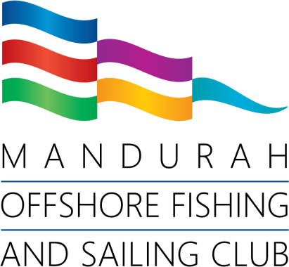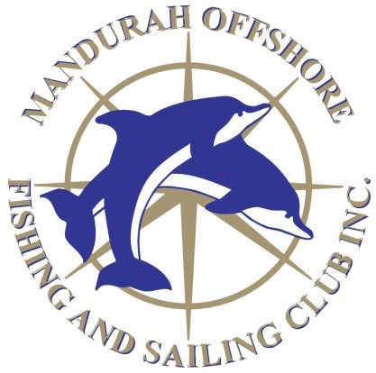
Monthly Fishing Competitions 2026/2027

TEAM NOMINATION FORM

- Team Captain to complete this nomination form.
- Maximum 3 competitors per team
- Only available to MOFSC members
- To be eligible for annual awards, Teams must enter a minimum of 4 competitions.
- Entry envelopes to include all team members competing and team name.
- Each competitor must complete an individual nomination form.
- Each competitor must pay individual competition fees.
- There is no additional cost to be a team.
- Scoring Sum of points of each team member
- In the event of equal points, the first fish/team weighed in shall win.

Team/Boat name

Team Captain/Skipper

Team member name

Team member name

