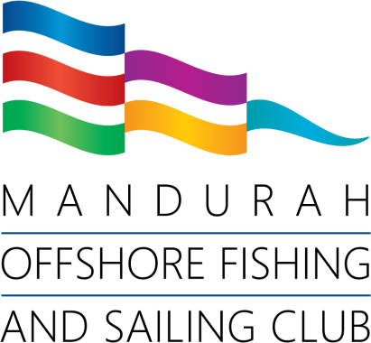

Monthly Fishing Competitions
2026/2027

INDIVIDUAL NOMINATION FORM

(please circle one) Men’s Ladies Juniors Up to 17 yrs. as at 1 OCTOBER 2026

Surname First name

Email Phone

Emergency Contact Parent/Guardian
Relationship
Phone

Nomination (once a competition season)
Every competitor to fill in this annual nomination form (avail on the website, or from the
yellow Fishing box near the stairs/bar entry) and return to the Fishing Committee.

Competition ENTRY envelopes (EVERY competition even if paid for the season) Entry envelopes must be filled in whether fishing from a land-based location or putting to sea. Skippers are reminded to log on/off with Mandurah Volunteer Marine Rescue.

Entry fees
Juniors (and junior visitors) 6-17 years of age no charge
Casual (and visitors) $10 each competition
Annual (members only) $60 the competition season

I certify that the above information is correct, and I agree to abide by the rules and regulations current for this event. I acknowledge that all competitors participating in the competition do so entirely at their own risk and the organizers, their agents, and Mandurah Offshore Fishing and Sailing Club, will not be held responsible in any way what- soever for loss, injury or damage sustained by my participation in this Competition.

Signed:
(Parent/Guardian for Juniors)
Date:

