Prophix Summer Racing Season
October 2026 to April 2027
Sailing Instructions and Handbook
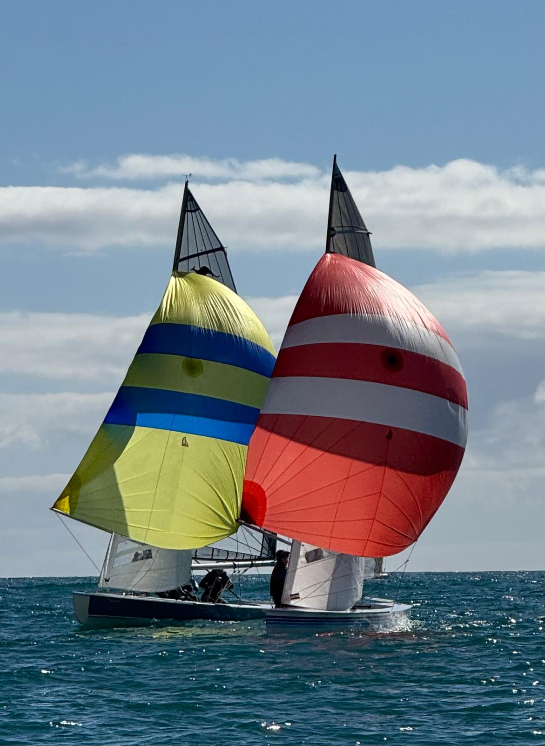

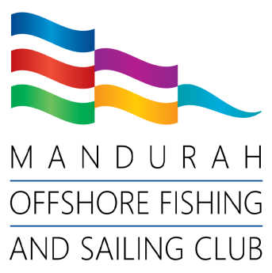
Photo courtesy of Annette Walker

(08) 9535 6521mofsc.com.au115 Breakwater Parade Mandurah WA 6210

The latest, full-colour version of this handbook is available on the MOFSC website:
mofsc.com.au/on-water/sailing
CONTACTS
MOFSC - Sail Captain | Basil Collins | 0416 671 956  cs@mofsc.com.au
MOFSC - Dinghy Captain | Kristian Sikora | 0402 082 732  cd@mofsc.com.au
Race Officers  Dinghy - Assistant RO | Les Woods  Bill Bargerbos  Jo Terry | 0409 081 466  0408 814 189  0448 557 709
Keelboat Results Officer  mofsc.keelboats@gmail.com | Vern Wright  Mike Philippe | 0423 967 572  0490 714 371
Dinghy Results Officers  mofscdinghy@gmail.com | Ally Boocock  Robin Holmes | 0432 639 376  0400 226 836
Volunteer Coordinators | Heather Dunlop-Hol  Annette Walker | 0433 311 646  0419 954 742
Race Support Tower  Call Sign: Mandurah Tower | Patrick O’Hara | 0458 761 705  Channel 74
MOFSC Clubhouse | 9535 6251
Mandurah Volunteer Water Rescue | 9535 4789 | Channel 16, 77 or 82

The keelboat section of the MOFSC are very pleased to welcome Prophix aboard this season as they have agreed to be our major sponsor. We hope you embrace their support as we move into another great season of Summer Sailing.
Prophix® is a global leader in financial performance management, empowering finance teams to lead with clarity, capacity, and confidence. From planning and budgeting to forecasting, reporting, reconciliation, and consolidation, Prophix brings it all together in one intelligent platform.
Prophix One™, the flagship Autonomous Finance Platform, combines AI, automation, and intuitive technology to simplify complex work and elevate finance to a more strategic role. With nearly four decades of innovation and a global footprint serving more than 3,000 customers in 100+ countries, Prophix is the trusted partner for organisations ready to transform finance into the driving force behind business growth.
Learn more at prophix.com/au


FOREWORD
Welcome to the 2026-27 Prophix Summer Racing Season at the Mandurah Offshore Fishing and Sailing Club.
In this handbook you will find:
- a description of the competitions for keelboats and dinghies that are to be held over the season.
- Sailing Instructions for the main club competitions
- the courses and their constituent marks; and
- the 2026-27 race program.

RACING RULES OF SAILING
These Sailing Instructions have been prepared to supplement the Racing Rules of Sailing (the Blue Book) and all sailors should obtain a copy of the Blue Book and be familiar with its rules and prescriptions. The Racing Rules of Sailing (RRS) are available for free download at: https://www.sailingresources.org.au/rules-hub/rrs/
Changes to the Official Australian Sailing RRS will constitute a change to the rules applied to our season.

ENTRY AND REGISTRATION
All on-water competitors must be registered, and registration fees paid in order to be considered eligible for the event. All crew of a competing vessel must be registered to be eligible to compete in an event for that vessel to be considered eligible.

Keelboat Registration (Boat)  Control Click here or use QR code below: | Dinghy Registration – (Boat)  Control Click here or use QR code below:
 | 
Keelboat Crew Registration  Control Click here or use QR code below: | Dinghy Crew Registration  Control Click here or use QR code below:
 | 

NEW AND PROSPECTIVE RACERS
New members and new sailors are encouraged to invest some time on the Club’s race support vessels (Mistral, Comet Queen and Club RIB’s) which is one of the easiest and most effective ways of learning about club keelboat and dinghy racing.
If you are interested in participating as a Club Volunteer, please contact the On Water Coordinator, the Keelboat Captain, or Dinghy Captain, or the Mandurah Offshore Fishing and Sailing Club office.

OFFICIAL SAILING NOTICE BOARD
Changes to the Sailing Instructions and additional notices will be posted on the Sailing Notice Board, located near the south-western entrance to the Club House.

RACECOURSE ETIQUETTE
All sailors, including dinghies, are asked to alert the Race Committee Vessel that you are intending to race on the day by sailing past the starboard side of RC Vessel as you enter the race area. The Race Committee can use this opportunity to confirm your attendance and that they have your correct boat details.

BE ALERT FOR DINGHIES
In accordance with IRPCAS and RRS, as a Skipper you have responsibility to maintain a watch for other boats – including dinghies - and to take all measures necessary to avoid collision, regardless of who has right of way. As dinghy courses overlap within keelboat courses, please provide ample clearances around dinghy turning marks.

KEELBOAT SAILING COMMITTEE
The MOFSC Sailing Committee (Keelboats) operates under the requirements of the club’s constitution and by-laws and meets on the afternoon or evening of the second Thursday of each month of summer (unless otherwise notified). All members are welcome to attend and listen or offer input. Details of meetings will be advised by email, via the committee and WhatsApp group. The Sailing Committee administers all keelboat sailing events held at the club and the more people who are involved at a committee level translates directly to the range and success of those events.

DINGHY SAILING COMMITTEE
The Dinghy Sailing Committee meets monthly on the night of the first Thursday of each month at 19.00. Details are advised by email, and via the committee WhatsApp group.

END OF SEASON PRESENTATION NIGHT
The first Saturday in May is generally accepted as the Sailing Presentation Night and is held in the Club Galley. If there is a conflict of bookings, date adjustments will be made to accommodate.
Keep an eye out for the posters and reserve a table once a date is selected. 1st May is the initial date proposed at the time this booklet goes to print.

RULES

The racing will be governed by the rules as defined in the Racing Rules of Sailing (RRS), unless stated otherwise in these Sailing Instructions.

The Prescriptions and Special Regulations of Australian Sailing will apply, unless stated otherwise in these Sailing Instructions.

Appendix T in Racing Rules of Sailing – Arbitration shall apply in case of protests.

CLASSES/FLEETS AND CLASS/FLEET FLAGS

Fleets, Divisions and associated class flags are as shown below. All boats in Division 1-4 must display their respective class flag when racing or entering or leaving the race area (does not apply to Code 'F' or Dinghies).
SPINNAKER FLEET | 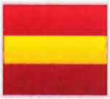 | DIVISION 1  Performance keelboats with or without spinnakers; and multihulls  Class Flag: Naval Numeral 1
SPINNAKER FLEET |  | DIVISION 2  Solings, Sports boats  Class Flag: Naval Numeral 2
JIB & MAIN FLEET |  | DIVISION 3  Keelboats without spinnakers  Class Flag: Naval Numeral 3
JIB & MAIN FLEET |  | DIVISION 4  Trailer Sailors without spinnakers  Class Flag: Naval Numeral 4
 |  | FLEET START (All keelboats)  Code Flag 'F'
 |  | DINGHY MIXED FLEET will use Sharpie Class flag
 |  | INDIVIDUAL DINGHY CLASSES will use their own class flag

RACING AREAS, COURSES, COURSE FLAGS AND MARKS

The racing areas, courses, associated course flags and course marks are identified in Attachment A.

SCHEDULE OF RACES

The Schedule of Races is provided in Attachment C.

NOTICES TO COMPETITORS

Notices to all competitors will be posted on the Official Sailing Notice Board located near the southwest entrance of MOFSC Clubhouse. In addition to the Notice Board, notices to competitors may be updated on the MOFSC website, What's App group and Facebook Page.

CHANGES TO SAILING INSTRUCTIONS

Any changes to the Sailing Instructions will be posted on the Official Sailing Notice Board not less than two hours before the scheduled start of the first race it will affect, except that any change in the Schedule of Races will be posted by 1800 on the day before it will take effect. Code Flag 'L' will be flown from the signal mast (see paragraph 4.1) when a 'change of sailing instructions is posted.'

SIGNALS MADE ASHORE

Signals made ashore will be displayed from the signal mast on the lawn to the southwest of the MOFSC clubhouse.

When flag AP is displayed ashore, '1 minute' is replaced with 'not less than 30 minutes' in the race signal AP.

RACE COMMITTEES

The Keelboat Race Committee shall consist of the Captain Sail, the Race Officer, and a representative from each fleet, where available. Three members present comprise a quorum to make decisions.

The Dinghy Committee shall consist of the Captain Dinghy, and at least three dinghy representatives. Three members (including the Captain) present comprise a quorum to make decisions.

OFFICIAL VESSELS

The start and finish Vessels shall display an MOFSC burgee/ID. Other official boats may display a green and white flag or MOFSC burgee/ID.

RADIO COMMUNICATIONS

During the period of the event, the Race Committee Vessel or the Control Tower may be contacted on VHF Channel 74. Participants should only contact the Race Committee Vessel regarding matters of importance. Radio silence from competitors during race start sequences is essential.

During the period of the event, competing boats should not radio other competing boats, except for emergencies and other critical matters.

While racing, a competitor shall not receive radio transmissions or mobile phone calls that may offer a racing advantage for the boat that are not available to all competitors.

A boat failing to comply with paragraph 10.3 may be scored DSQ without a hearing.

ELIGIBILITY/ENTRY AND INSURANCE

In accordance with the MOFSC By-Laws, Keel boats in club events shall be eligible for a boat prize only if all crew on-board are financial members of the club or have registered as part of the SailPass “Try Sailing” system (maximum of 3 races per season).

Prior to racing, all entrants intending to race shall Register and pay for the relevant class/division they intend to sail on REVSPORT. Alternatively, a person intending to race may complete a SailPass Registration on REVSPORT. All links are available in the Sailing and Dinghy Sections on the Club’s Website.

All skippers must submit to MOFSC an Insurance Certificate of Currency valid for all (or parts sailed) of the racing season. A Certificate of Currency that expires during the racing season must be resubmitted as valid on or prior to the expiry date. The minimum level of cover is Third Party Liability and Public Liability Insurance of not less than AU$10,000,000.
CATEGORY (All prices include GST) | MEMBER? | FEE
Keelboat – boat MUST REGISTER | Yes | $130
Keelboat Crew - MUST REGISTER | Yes | $0
Dinghy - boat (Season) MUST REGISTER | Yes | $110
Dinghy Crew MUST REGISTER | Yes | $0
SailPass (max. of 3 race days per season) MUST REGISTER | No | $0

SAFETY REGULATIONS

All competing Keelboats shall submit the appropriate 'Special Regulations Equipment Compliance Form' with the club equipment auditor as part of their entry and eligibility. A boat failing to submit the form will not be deemed eligible to race or be eligible to receive any trophies or prizes. (These forms are also available at the sign-on desk in the rear foyer)

Div 1-4 boats shall comply with Category 6 safety requirements.

Soling’s sailing in Div 2 shall comply with Category 6 Modified safety requirements.

12.4 Dinghy fleet shall comply with Australian Sailing Off The Beach (OTB) Compliance Card requirements.

All persons aboard a vessel without safety rails shall wear a PFD type 1 or PFD type 2 when afloat.

A boat or equipment may be inspected at any time for compliance with the class rules and sailing instructions. On the water, a boat can be instructed by a member of the Race Committee to proceed immediately or within a specified timeframe to a designated area for inspection. A boat failing to comply with any paragraph in this section shall be scored DSQ without a hearing.

ADVERTISING

Boats may display advertising only when approved or instructed by the Race Committee.

SIGN ON/OFF

All Keelboat skippers shall sign-on prior to racing in any session. Sign-on shall include all crew and or changes to crew and will be done by completing the "sign-on sheet" located on the table in the foyer area to the west of the bar and below the MOFSC tower or/and by calling "Mandurah Tower" on Ch 74.

Dinghy skippers will be required to sign on prior to their race by completing the "sign-on sheet" located on the table in the foyer area to the west of the bar and below the MOFSC tower
14.2 All skippers shall sign off within 45 minutes of completing their race or retiring that session, by the means described in SI 14.1

A boat failing to comply with SI 14.1and/or SI 14.2 may be scored DSQ without a hearing.

THE START

Races will start upwind using Rule 26.

The starting line will be between the staff displaying the orange flag on the Race Committee Vessel at one end and a black and white checked buoy at the other end of the line.

Prior to the commencement of the first starting sequence, all Keel Boats entering the course should approach the Race Committee Vessel towards her starboard side for the purposes of identification by the Recorder, displaying her Class Flag.

Fleets/Classes will typically be started in the order of the start times shown on the schedule of events “Attachment C” (The actual start times may be delayed at the discretion of the Race Officer, using the AP Flag.)

[DP] During the starting procedure of a fleet, the boats that are not part of that fleet shall keep a clear distance from the starting line, in each direction. In such a case, where a boat which crosses the start line whilst another class is in starting sequence on the same line may be assigned a Discretional Penalty.

Dinghy races will be started using a 3-minute countdown sequence. This changes RRS Rule 26

Dinghy signals will be made at one-minute intervals. The timing, flags, and sound signals will be as follows
Time before start | Visual Signal (Flag) | Sound Signal | Means
3 Minutes | Class/Division flag raised | One sound | Warning Signal
2 Minutes | Preparatory Flag raised | One sound | Preparatory Signal
1 Minute | Preparatory Flag lowered | One long sound | One – Minute Signal
0 Minutes (Start) | Class/Division flag lowered | One sound | Start Signal

A Keel Boat starting later than 4 minutes after her starting signal will be scored Did Not Start (DNS) without a hearing. This changes Rule A5.1

A Dinghy that does not start within 3 minutes after her starting signal may be scored Did Not Start (DNS) at the discretion of the race officer. This changes RRS A5.1 and A5.2.

When more than one race will be held on the same day for the same class the warning signal for each subsequent race will be made as soon as practicable after the completion of the previous race. To alert competitors and coaches that the next race will commence, the Race Committee may sound a long sound signal and display an orange flag.

Handicap Start Procedure: Rule 26 is deleted and replaced with the procedure that follows.
10 minutes | The course flag will be displayed
5minutes: | Warning Signal Code Flag 'F' (All classes)
4minutes: | Preparatory Signal
1minute: | Preparatory Signal removed
Starting Signal: | Code Flag 'F' removed = highest number 30 drops …. Each number thereafter follows with an oral countdown sequence on VHF radio channel VHF 74 – as such: “…5…4…3…2…1..(drop number)”

A boat's allotted (handicap) fall number will be displayed on the Official Sailing Notice Board at least three hours prior to the scheduled race start.

Boats shall start at or after the fall “when their drop number is announced” for their allotted handicap number.

A boat starting before the fall of her allocated handicap number will be penalised 2 penalty minutes plus 1 minute for each full minute or part thereof that she starts early. This penalty will be added to her actual finishing time for the race. Recall signals will not be made.

CHANGE TO THE NEXT LEG OF THE COURSE

During a race, the Race Officer may direct that a mark, gate or finish line be moved to a new position or returned to its original position.

THE FINISH

Race Committee Vessel Finish: There can be 2 active finish lines, they are:

Between the Port Staff displaying the blue flag on the Race committee vessel and the Port Pin (a black and white checked buoy)

Between the Starboard Staff displaying the blue flag on the Race committee vessel and the Starboard Pin (a black and white checked buoy)

For keelboat upwind finishes, the finish line is on the PORT side of the Race Committee Vessel. For all dinghy finishes and for any downwind keelboat finishes, the finish line is on the STARBOARD side of the Race Committee Vessel.

Any competing boat that has completed the course and crosses the finish line while the Race Committee Vessel is flying the blue flag (see Attachment D) will be deemed to have finished her race.

Tower Finish: The finishing line will align with the MOFSC Race Control Tower and the Point Robert cardinal mark. The finishing line will be defined by the Point Robert Cardinal Mark to seaward and an inflatable mark positioned inshore of that mark. Boats approaching the finish line shall alert the tower of their sail number.

ALL COMPETING BOATS shall not cross any finish line (See SI 17.1 for definition on Finish Line. Blue Flag is flying) unless finishing. For clarification, this applies to dinghy and keelboats for either fleets finish line.

After finishing, ALL COMPETING BOATS shall keep clear of ALL FINISHING LINES.

A boat failing to comply with SI 17.5 shall have a Scoring Penalty of 30% added to their boat’s points (SCP) at the discretion of the Race Officer (RO)

TIME LIMITS - Keelboats

Round the Marks: The time limit for the first boat to finish shall be 3 hours. A boat failing to finish within 45 minutes after the first boat in its division/class will be scored Did Not Finish (DNF) without a hearing.

Windward/Leeward Series: The time limit for the first boat to finish in each division shall be 60 minutes. A boat failing to finish within 20 minutes after the first boat in its division/class will be scored Did Not Finish (DNF) without a hearing.

Coastal Races: The latest time for finishing Coastal Races is 1700. A boat finishing later than 1700 shall be scored Did Not Finish (DNF) without a hearing.

All races shall be abandoned if not finished within daylight hours.

TIME LIMITS – Dinghies

For Dinghies, the time limit for the first boat to finish in each division shall be 60 minutes. A boat failing to finish within 20 minutes after the first boat will be scored Did Not Finish (DNF) at the discretion of the Race Officer.

PENALTY SYSTEM

Rule 44.1 is changed so that the Two-Turns Penalty is replaced by the One-Turn Penalty (the turn to be taken as soon as is safely possible and not hindering or endangering other competitors)

OUTSIDE ASSISTANCE

The Race Committee Vessel or a support vessel may retrieve crews and return them to their boats for safety reasons. Outside help while racing shall be reported to the Race Committee before sign-off on the day concerned.

The relevant Race Committee may decide to use on-water umpiring at any time.

PROTESTS AND REQUESTS FOR REDRESS

Protest forms are available at the Official Sailing Notice Board in the MOFSC Clubhouse. Protests and requests for redress or reopening shall be delivered to the person manning the tower within 60 minutes of the finishing time of the last boat of that division/class for the last race of the day or later at the discretion of the Race Committee. One representative of each boat shall be available immediately for the arbitration hearing.

Notices will be posted on the official notice board within 30 minutes of the Protest Time limit to inform competitors of hearings in which they are parties or named as witnesses.

SCORING

The Low Point scoring system of RRS Appendix A will apply (Attachment B). Rule A9 is amended as follows:

A boat that came to the starting area but did not start, did not finish, retired before finishing or was disqualified, shall be scored points for the finishing place ONE more than the number of boats that came to the starting area.

A keel boat that did not come to the starting area shall be scored points for the finishing place 2 more than the number of boats that came to the starting area. For dinghies, 5 more than the number of boats that came to the starting area.

Three races are required to be completed to constitute a series. A boat that does not complete three races in any series will be considered ineligible for that series and the scores of other eligible boats will be adjusted accordingly.

When fewer than five races have been completed in a series, a boat's series score will be the total of her race scores.

When from five to seven races have been completed in a series, a boat's series score will be the total of her race scores excluding her (one) worst score.

When eight to ten races have been completed in a series, a boat's series score will be the total of her race scores excluding her two worst scores.

When eleven or more races have been completed in a series, a boat's series score will be the total of her race scores excluding her three worst scores.

For the Dinghy Consistency Series, there will be one drop per five races sailed.

A boat, requested by the Race Committee to volunteer instead of race for the day's events, will be scored average points for each of those events.

Dinghy finishing times will be posted on the Official Notice Board as soon as possible after racing and results posted on Sportspage as soon as possible, accessible via the MOFSC website.

After their announcement, Keelboat placings will be posted on the Official Notice Board and posted on Sportspage as soon as possible, accessible via the MOFSC website.

PRIZES

Pennants will be awarded to places, as shown below, decided on handicap as well as fastest for each fleet/class, except for Handicap Start events.
For a fleet consisting of four or more boats: | 1st, 2nd and 3rd places
For a fleet consisting of three boats: | 1st and 2nd places
For a fleet consisting of two boats: | 1st place only

Announcement of results will take place in the Wormall Developments Marina Bar prior to 1800 hours after racing on Saturdays.

All attempts will be made to approach Yachting Australia to obtain and apply for "yard-stick" information on all competing keelboats, if there is to be a "Yard-Stick Trophy for the 2026 / 27 season.

DISCLAIMER

Competitors participate in races and or enter regattas entirely at their own risk. See RRS 4, Decision to Race. The organising authority will not accept any liability for material damage or personal injury, or death sustained in conjunction with or prior to, during, or after the race / regatta.

LIST OF ATTACHMENTS
Attachment A: Racing Areas, Courses, Course Flags and Marks
Attachment B: Scoring System
Attachment C: Schedule of Events
Attachment D: Flags and Pennants
Attachment E: 5 Minute Start Sequence
Attachment F: 3 Minute Start Sequence (Dinghy)

ATTACHMENT A: RACING AREAS, COURSES, COURSE FLAGS AND MARKS
A1 RACING AREA
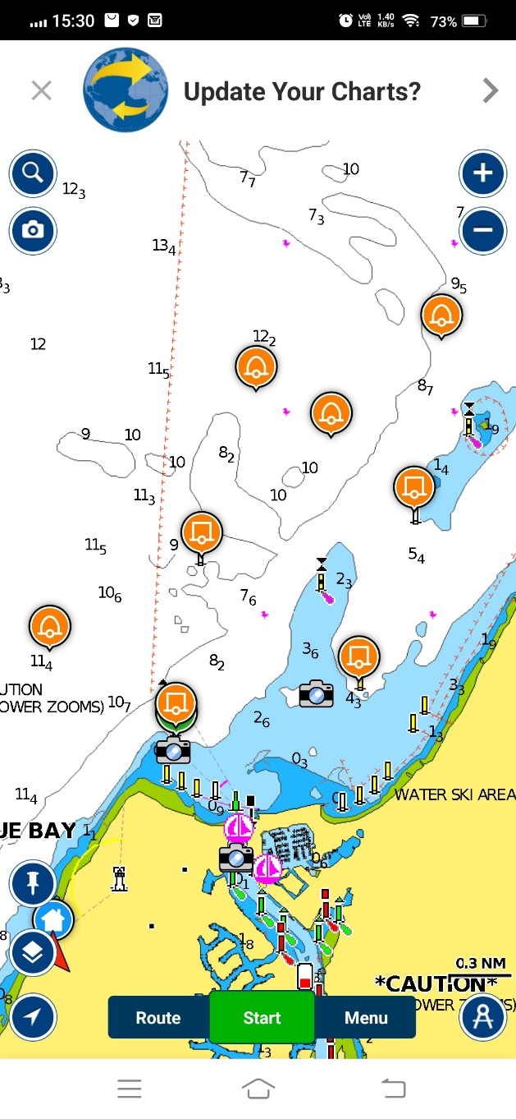
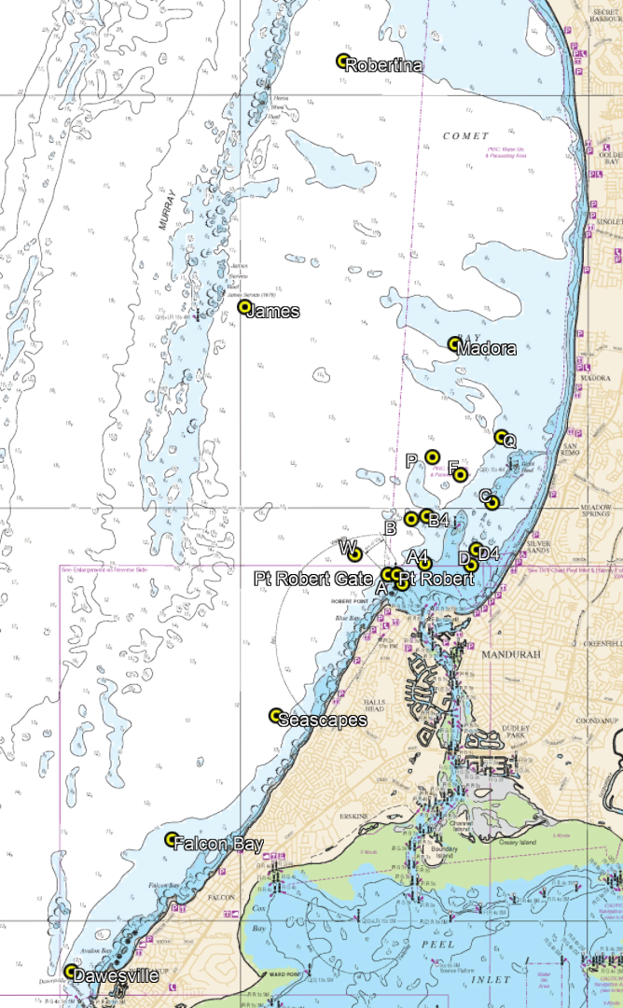
D4
B4
A4
A4
D
A
W
C
F
P
B
Q

A2 COURSE MARKS
The fixed and temporary course marks are as described in Table A1.
Table A1: Marks and positions used for keelboat races, except the Short Course
(all coordinates are approximate)
Mark/Position | Description and Coordinates (GDA94)
'A' Mark | Permanent vertical spar, S 32°30.93 E 115°42.29
‘A4’ Mark (Div 4 only) | Inflatable buoy, S 32°30.66 E 115°42.63
'B' Mark | Permanent vertical spar, S 32°30.12 E 115°42.44
‘B4’ Mark (Div 4 only) | Inflatable buoy, S 32°30.08 E 115°42.66
‘C’ Mark | Permanent vertical spar, S 32°29.93 E 115°43.60
'D' Mark | Permanent vertical spar, S 32°30.69 E 115°43.30
‘D4’ Mark (Div 4 only) | Inflatable buoy, S 32°30.49 E 115°43.38
‘F’ Mark | Inflatable buoy, S 32°29.58 E 115°43.14
‘P’ Mark | Inflatable buoy, S 32°29.37 E 115°42.74
‘Q’ Mark | Inflatable buoy, S 32°29.13 E 115°43.74
‘W” Mark | Inflatable buoy, S 32°30.55 E 115°41.63
Point Robert Cardinal Mark | DoT North Cardinal Mark, S 32°30.80 E 115°42.24
Point Robert Seaward Buoy (Gate) | Inflatable buoy, approximately 200m seaward of Point Robert Cardinal Mark
Seascapes Buoy | Inflatable buoy, S 32°32.50 E 115°40.50
Falcon Bay Buoy | Inflatable buoy, S 32°34.00 E 115°39.00
Dawesville Buoy | Inflatable buoy, S 32°35.60 E 115°37.55
Madora Bay Buoy | Inflatable buoy, S 32°28.00 E 115°43.07
James Service Buoy | Inflatable buoy, S 32°27.55 E 115°40.05
Robertina Buoy | Inflatable buoy, S 32°24.57 E 115°41.47
Day Buoy | Inflatable yellow buoy upwind of start line

A3 KEELBOAT COURSES AND COURSE FLAGS
A3.1 General
Courses will be one of the following types:
- Round the Marks
- Short Course
- Coastal Courses
Start times are provided in the Events Schedule (Attachment C).
A3.2 "Round the Marks"
Club Champion, Consistency and Handicap Start race series will utilise the fixed marks A through D with the addition of P - F - Q and W as their principal racecourse. The approximate locations of the fixed marks are shown in Table A1.
The sequence of marks has been pre-determined for twelve (12) different courses (6 port and 6 starboard) as set out for each fleet/class in Table A3. The course and direction of rounding for all marks will be indicated on the day by the display of a Course Flag and a Rounding Flag (i.e, port or starboard) from the Race Committee Boat, at least 5 minutes prior to the commencement of the starting sequence for the first race.
The race will start and finish to windward at the Race Committee Boat, as described in the Sailing Instructions. Estimated race time is 1.5 to 2 hours; maximum race time is 3 hours.

A3.3 Short Course
The Short Course race series uses a windward-leeward course that will be set on the day according to the wind and at the discretion of the Race Officer. The windward mark for SW conditions, will be the club "A Mark" for Division 1-2-3 and a YELLOW CYLINDRICAL INFLATABLE BUOY for Division 4; The leeward marks will be a gate consisting of two yellow inflatable buoys. The course layout is shown in Figure A2, with two laps of the course counting as a race. Two races (starts) will be held each event. Extra (or fewer) races may be held as part of the event at the discretion of the Race Officer. Should the wind not be SW then using a fixed mark and an inflatable upwind mark will be placed at the discretion of the Race Officer. Adjustments to course will be audio information and will be passed on by the RO and / or Mandurah Tower.
The race will start (upwind) and finish (downwind) at the Race Committee Boat.
Figure A2: Short Course layout
Division 4 keelboat windward yellow mark
Course 8 – Short Course – Numeral Pennant 8  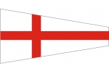  All Keelboats  Start - 1 - 2-1 - Finish (Starboard Finish)  NOTE: Mark 1B in the course figure is Division 4 windward Yellow mark ONLY Any orange marks are for Dinghy only | 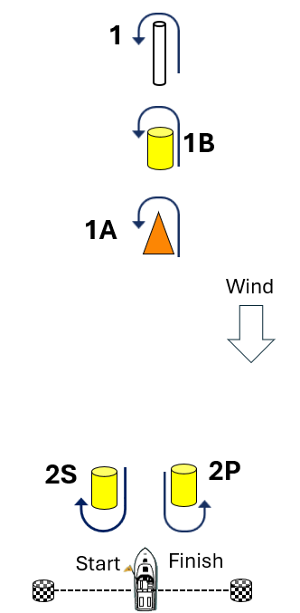  Dinghy Windward Orange Mark  Division 1-3 keelboat windward mark

A3.4 Coastal Races
The Coastal Race series uses a combination of fixed marks, cardinals, inflatable buoys, and geographical coordinates. The mark coordinates are set out in Table A1. The individual courses and the direction of rounding each mark is prescribed in Table A2.
Point Robert Cardinal is a North passing cardinal and as such, passing to the south (between the cardinal and the headland/beachhead during a race, will be deemed as DSQ - without protest.
Note: the chart-datum height of the Port Bouvard Bridge is 17.6 m at high tide.
Table A2: Coastal Race Courses
Event | Course
Madora Bay – Return | Start –Day buoy (P or S) - Madora Buoy(P) – B Mark (S) - Madora Buoy(S) - Finish.
Seascapes – Return | Start Day buoy (P or S) - Pt Robert (P) - Seascapes Buoy(S) –W Mark (P) - Seascapes Buoy (S) - Pt Robert (S) - D Mark (P) - Finish.  Div 4 is only lap only
Dawesville Race  Part 1 | Start – Day buoy (P or S) – Pt Robert (P) - Falcon Bay Buoy (S) –Dawesville finish line (vessel and Buoy)
Dawesville Race  Part 2 | Start – Day buoy (P or S) – Falcon Bay Buoy (S) – Pt Robert (S) – D Mark (P) – Finish
“Shipwreck Race”  James Service Race (S) | Start – Day buoy (S) – James Service Buoy (S) –Robertina Buoy (S) – Madora Bay Buoy (S) –C Mark (S) – Finish
“Shipwreck Race”  James Service Race (P) | Start – Day buoy (P) – Madora Bay Buoy (P) – Robertina Buoy (P) – James Service Buoy (P) – A Mark (P) - Finish

Note: The Dawesville race is set to run as a “there and back split race.” Each leg will count as an individual race. Please note the early start time and remain in contact via radio in case any unexpected weather event changes the return leg start time. At the turning point break, competitor vessels have the opportunity to enter the Dawesville Cut to avail of the Marina facilities or raft up off the beach just south of the cut. Lunch break activity / mooring choices are at the discretion of each competing vessel.
Table A3 Round the Marks Course Instructions
Fleet | Course and Flags |  |  | Sequence of Marks
Keelboat Divisions 1 - 3 | 1  (SW) |  | S | Start- A-B-C-A-C-A-B-C- Finish 6.7NM
Keelboat Divisions 1 - 3 | 1  (SW) |  | P | Start- A-D-C-A-C-A-D-C- Finish 7.0NM
Keelboat Divisions 1 - 3 | 2  (SE) |  | S | Start- D-A-B-D-B-D-A-B- Finish 6.7NM
Keelboat Divisions 1 - 3 | 2  (SE) |  | P | Start- D-C-B-D-B-D-C-B- Finish 7.0NM
Keelboat Divisions 1 - 3 | 3  (NE) | 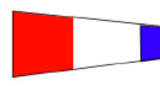 | S | Start- C-D-A-C-A-C-D-A- Finish 9.3NM
Keelboat Divisions 1 - 3 | 3  (NE) |  | P | Start- C-B-A-C-A-C-B-A- Finish 9.7NM
Keelboat Divisions 1 - 3 | 4  (NW) |  | S | Start- B-C-D-B-D-B-C-D- Finish 7.3NM
Keelboat Divisions 1 - 3 | 4  (NW) |  | P | Start- B-A-D-B-D-B-A-D- Finish 7.1NM
Keelboat Divisions 1 - 3 | 5  (SW) |  | S | Start- A-P-C-D-A-B-D - Finish 6.8NM
Keelboat Divisions 1 - 3 | 5  (SW) |  | P | Start - A–D-C-P-B-A-D- Finish 6.8NM
Keelboat Divisions 1 - 3 | 6  (SE) | 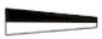 | S | Start - D-A-P-C-D-A-P-C-D- Finish 9.0NM
Keelboat Divisions 1 - 3 | 6  (SE) |  | P | Start - D-C-P-A-D-C-P-A-D- Finish 9.0NM
Fleet | Course and Flags |  |  | Sequence of Marks
Keelboat Division 4 | 1  (SW) |  | S | Start-A-B-C-A-C- Finish
Keelboat Division 4 | 1  (SW) |  | P | Start-A-D-C-A-C- Finish
Keelboat Division 4 | 2  (SE) |  | S | Start-D-A-B-D-B-Finish 4.5NM
Keelboat Division 4 | 2  (SE) |  | P | Start-D-C-B-D-B-Finish 4.6NM
Keelboat Division 4 | 3  (NE) |  | S | Start-C-D-A-C-A-Finish
Keelboat Division 4 | 3  (NE) |  | P | Start-C-B-A-C-A-Finish
Keelboat Division 4 | 4  (NW) |  | S | Start-B-C-D-B-D-Finish 5.4NM
Keelboat Division 4 | 4  (NW) |  | P | Start-B-A-D-B-D-Finish 4.5NM
Keelboat Division 4 | 5  (SW) |  | S | Start- A-B-C-D-A-B-D - Finish 6.2NM
Keelboat Division 4 | 5  (SW) |  | P | Start -A–D-C-B-A-C -D- Finish 6.2NM
Keelboat Division 4 | 6  (SE) |  | S | Start - D-A-B-C-D-A-B-C-D- Finish 7.4NM
Keelboat Division 4 | 6  (SE) |  | P | Start - D-C-B-A-D-C-B-A-D- Finish 7.4NM

A4 DINGHY COURSES AND COURSE FLAGS
Marks will be green, yellow, orange, pink or red inflatable buoys.
All courses are port rounding’s unless a green starboard flag is displayed from the Race Committee Boat.
All Dinghy finishes are on the Starboard side of the Committee Boat
Course 5 - Trapezoidal Course - Numeral Pennant 5
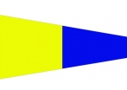  Optimist, Mudlark, Minnow  Start -1-2-3-4- Finish  Pacer, RS Feva, Open Bic, Flying Ant  Start -1-2-3-2-3-4- Finish  Cherub, Impulse, Hobie Wave, Laser Standard, Radial, 4.7 RS Aero, Sharpie, Tasar, Fireball, 420, 505, 29er, Shark, OK  Start –1-2-3-2-3-2-3-4-Finish |  | 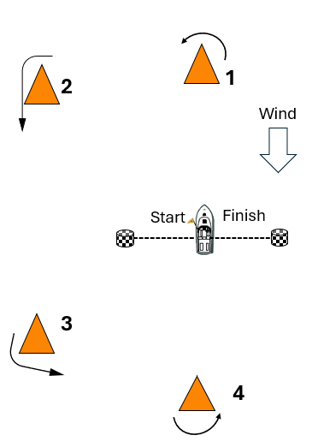
Course 6 - Windward Return - Numeral Pennant 6
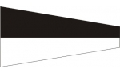  Optimist, Mudlark, Minnow  Start -1-2-Finish  Pacer, RS Feva, Open Bic, Flying Ant  Start -1-2-1-2- Finish  Cherub, Impulse, Hobie Wave, Laser Standard, Radial, 4.7 RS Aero, Sharpie, Tasar, Fireball, 420, 505, 29er, Shark, OK  Start –1-2-1-2-1-2-Finish |  | 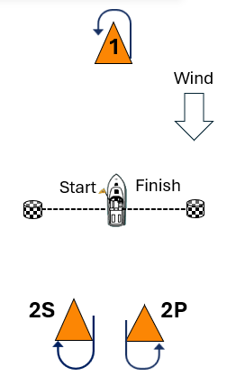
Course 7 – Triangle /Windward Return – Numeral Pennant 7
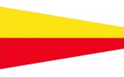  Optimist, Mudlark, Minnow  Start -1-2-3-Finish  Pacer, RS Feva, Open Bic, Flying Ant  Start -1-2-3-1-3- Finish  Cherub, Impulse, Hobie Wave, Laser Standard, Radial, 4.7 RS Aero, Sharpie, Tasar, Fireball, 420, 505, 29er, Shark, OK  Start -1-2-3-1-3-1-2-3-Finish | 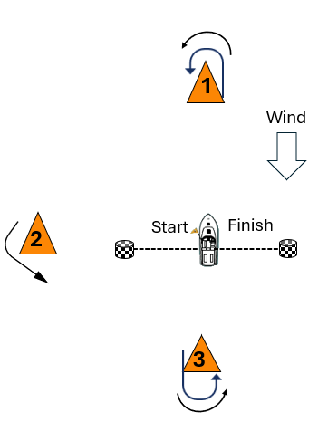
Course 8 – Short Course – Numeral Pennant 8 Downwind finish
Optimist, Mudlark, Minnow  Start -1A-Finish  Pacer, RS Feva, Open Bic, Flying Ant  Start -1A-2-1A- Finish  Cherub, Impulse, Hobie Wave, Laser Standard, Radial, 4.7 RS Aero, Sharpie, Tasar, Fireball, 420, 505, 29er, Shark, OK  Start -1A-2-1A-2-1A-Finish  NOTE:  2S & 2P will be yellow inflatable buoys  1A is an orange inflatable buoy  1B is a Keelboat windward yellow mark Div 4 keelboats ONLY  1 is windward Keelboat - normally A mark | 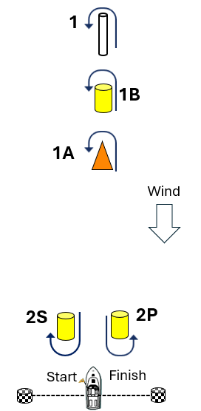  Dinghy Windward Orange Mark

Course 9 – Triangle
  Optimist, Mudlark, Minnow  Start -1-2-3-Finish  Pacer, RS Feva, Open Bic, Flying Ant  Start -1-2-3-1-2-3- Finish  Cherub, Impulse, Hobie Wave, Laser Standard, Radial, 4.7 RS Aero, Sharpie, Tasar, Fireball, 420, 505, 29er, Shark, OK  Start -1-2-3-1-2-3-1-2-3-Finish | 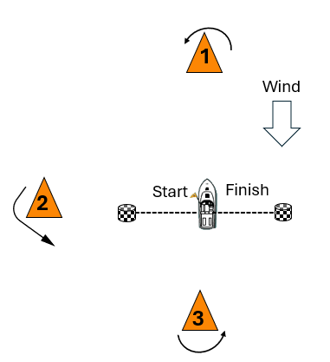

ATTACHMENT B: SCORING AND TROPHIES
All handicaps, yardsticks, scores and prizes shall be assigned or awarded at the sole discretion of the Race Committee.

Dinghies
B1 Championship Trophy
Single Fleets will be an over the line system and mixed fleets will be a yardstick system.
B2 Consistency Trophy
This will be calculated using a performance-based handicap system based on Yardstick values.
B3 The Burrows Family Diggers Cup
The race will be a fleet race using Australian Sailing regulation handicaps according to boat dimensions and type (Aus Sailing Yardstick).
B4 Short Course Trophy
This will be calculated using a performance-based handicap system. A fleet consists of at least 5 boats.

Keelboats
All races use performance handicap system.
B5 Female skipper Trophy – Awarded to the Female skipper of a keelboat for the Female Skipper race (Div 1-4)
B6 Junior Skipper Trophy – Awarded to the skipper of a keelboat for the Junior Skippers race (Div 1-4)
B7 Crew skipper Trophy – Awarded to the Crew as a skipper of a keelboat for the Crew Skippers race (Div 1-4)
B8 Consistency Trophy – Awarded to overall vessel winner (Div 1-4)
B9 Short Course Trophy – Awarded to overall vessel winner in this series (Div 1-4)
A fleet consists of at least 5 boats.
B10 RTM – Awarded to overall vessel winner in this series (Div 1-4)
B11 Ocean Races– Awarded to overall vessel winner in this series (Div 1-4)
The race will be a fleet race using Australian Sailing regulation handicaps according to boat dimensions and type (Aus Sailing Yardstick if and as available).
B12 Handicap start – Awarded to overall vessel winner in this series (Div 1-4)
A fleet consists of at least 5 boats.
B13 The Burrows Family Diggers Cup – Awarded to overall vessel winner in this series (Div 1-4)
The race will be a single/combined keelboat fleet race using Australian Sailing regulation handicaps according to boat dimensions and type (Aus Sailing Yardstick, if and as available).

.

ATTACHMENT C: SCHEDULE OF EVENTS

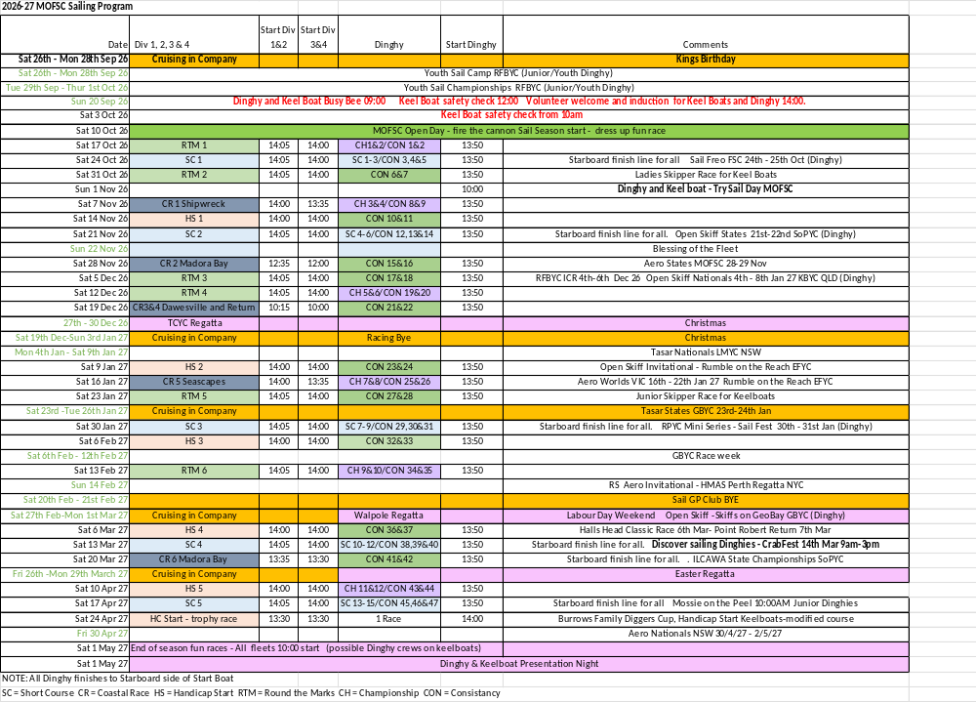
ATTACHMENT D: INTERNATIONAL CODES AND PENNANTS
INTERNATIONAL CODE FLAGS | 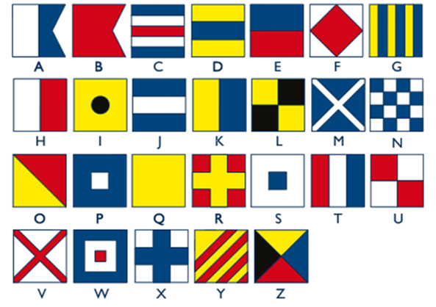
NUMERAL PENNANTS | 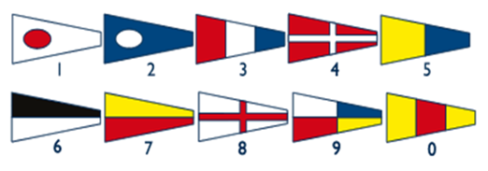
NAVAL NUMBER FLAGS | 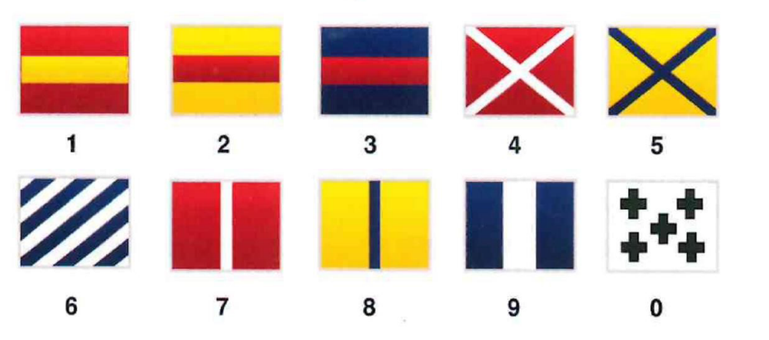
SUBS | 
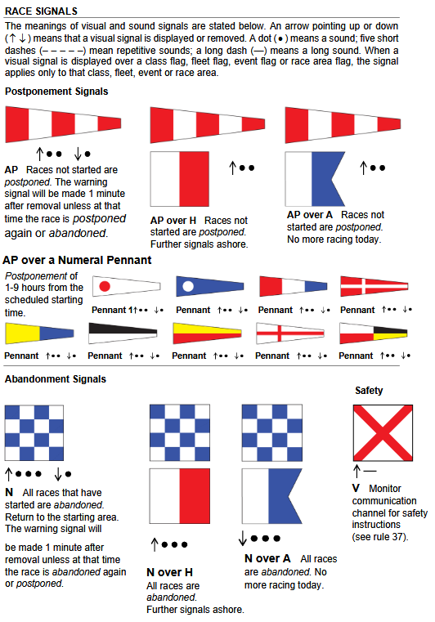
Code Flags and Race Signals

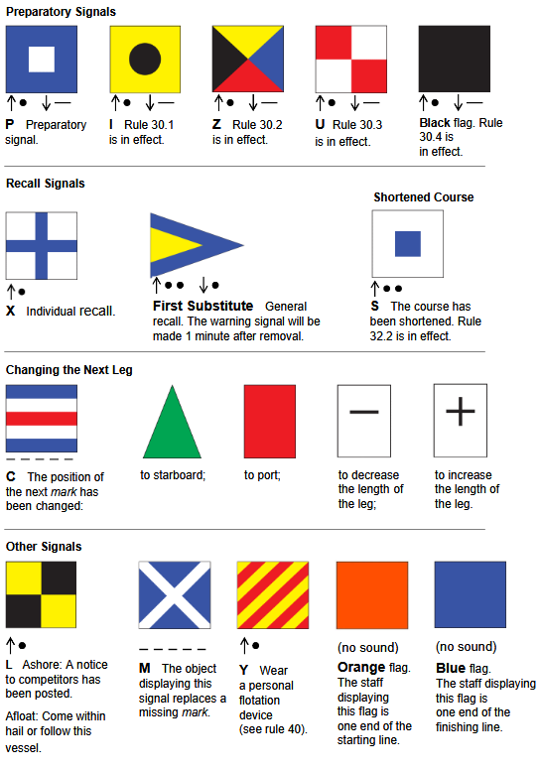
Code Flags and Race Signals (cont)

START SEQUENCE (Except Handicap Starts – See Sailing Instructions)
 | Orange Flag or Shape  “On Station for Starting” | The Race Boat is on station and a start sequence will be made soon (not less than 5 minutes).  Forms the Start Line with the pin-end buoy. Remains aloft.
 |  | YOUR NOTES
 | Class Flag Raised  “5 min to Start”  1 short blast  WARNING SIGNAL
 | Preparatory Flag Raised  “4 min to Start”  1 short blast
- | Preparatory Flag Lowered  “1 min to Start”  1 Long blast
Class Flag Lowered
“START!”
1 short blast
ATTACHMENT E: 5 MINUTE START SEQUENCE

DINGHY START SEQUENCE
 | Orange Flag or Shape  “On Station for Starting” | The Race Boat is on station and a start sequence will be made soon (not less than 5 minutes).  Forms the Start Line with the pin-end buoy. Remains aloft.
 |  | YOUR NOTES
Class Flag Raised
“3 min to Start”
1 short blast
WARNING SIGNAL
Preparatory Flag Raised
“2 min to Start”
1 short blast
- | Preparatory Flag Lowered  “1 min to Start”  1 Long blast
Class Flag Lowered
“START!”
1 short blast
ATTACHMENT F: 3 MINUTE START SEQUENCE

